**SAP BW/BO Exercise**

**BW Exercise 3 – Building Infoobjects**

**Student Name: Nupur Ray Student Id: nxr163130**

**Date: 08/09/2016 SAP ERP Login Id: F6-046**

**Note: You must use the following conventions to name objects/systems created in this exercise.**

**Replace S with A - for Fall semester**

**B - for Spring semester**

**C - for Summer semester**

**Replace YY with the last 2 digits of the current year.**

**Replace XXX with your SAP ID.**

**Part 1**

**Objectives:**

Develop an understanding of infoobject catalogs for Characteristics and Key Figures.

* Create Catalog Infoobjects
* Create Characteristic InfoObjects
* Create Key Figure InfoObjects

**Infoobject Catalog**: Unique Icon structure contained within an infoarea that lists the specific Characteristics and Key Figures that are available for use.

**Creating InfoObjects:** (Note: This part is very important as the characteristic catalog you make in this exercise is going to be used in further exercise to build your DSO. Make sure you follow the steps correctly to avoid any problems in later exercises.)

**Create Info Area**

Run Transaction RSA1 in the command field of your SAP System



OR

Double click on Administrator Workbench. i.e. SAP menu-> Modeling-> RSA1 - Administrator Workbench: Modeling

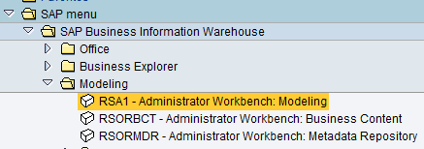

Click InfoObjects under Modeling in the left panel. On the right panel, right click on InfoObjects on the Tab as shown in the screenshot and select Create InfoArea.

Note: Double check you click on the InfoObjects field, but not on some of the objects already created.

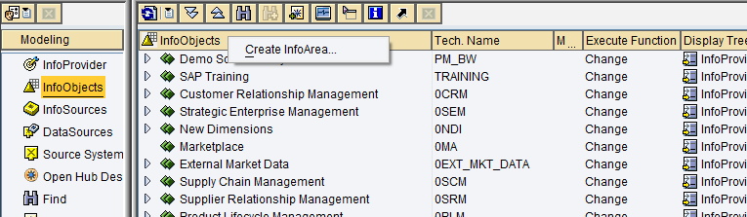

Enter the Name **InfoAreaSYYXXX** and description – Info Area **SYYXXX** for the Info area and then click to continue.

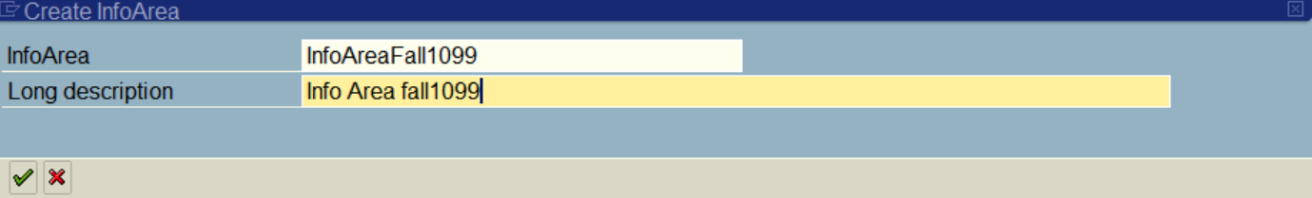

Select enter to create task. In this step you will have to create a workbench request.

**Note:** You may receive a warning asking you to create under another user’s name. Simply click on the green check mark.

Follow the below steps for creating the workbench request: -

Once you click on the continue icon in infoarea dialog box, you will get below **Create Task** pop up, click on green check button:

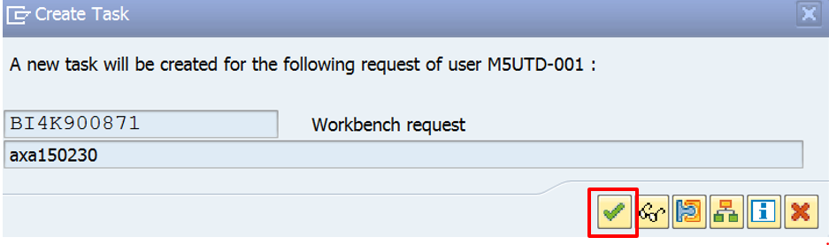

After clicking on the green check, below **Prompt for Local Workbench request** pop-up will appear, in this pop-up click on create button.

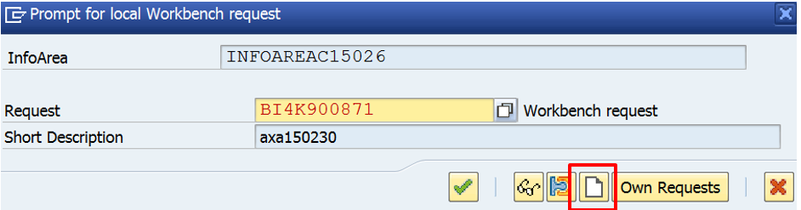

Click on the create button (highlighted in the above screenshot), below screen will appear, give some description for your request (for instance your user id or net id) and click on Save button

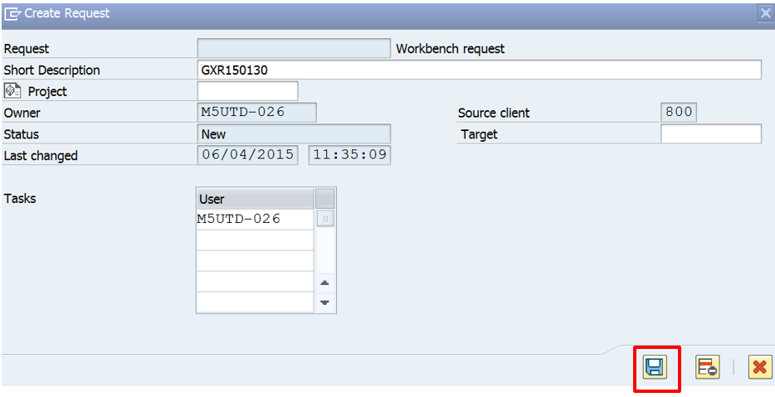

After clicking on Save button you will get below pop-up, in this pop-up just click on green check and you are done. You have completed creating a workbench request.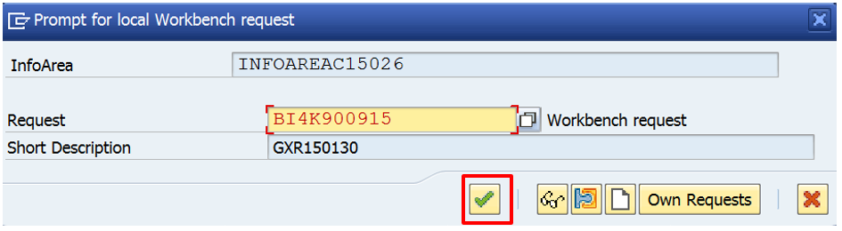

**Create Info Object Catalog**

Right click on the info Area created Info Area SYYXXX and select Create InfoObject Catalog...

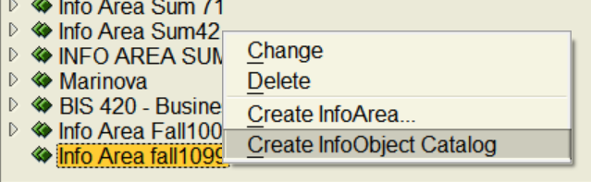

Enter a name- CharCatlogSYYXXX and a description (next textbox)- Character Catalog for the InfoObject Catalog, under InfoObject type- select the option Char., and then click to create the InfoObject Catalog.

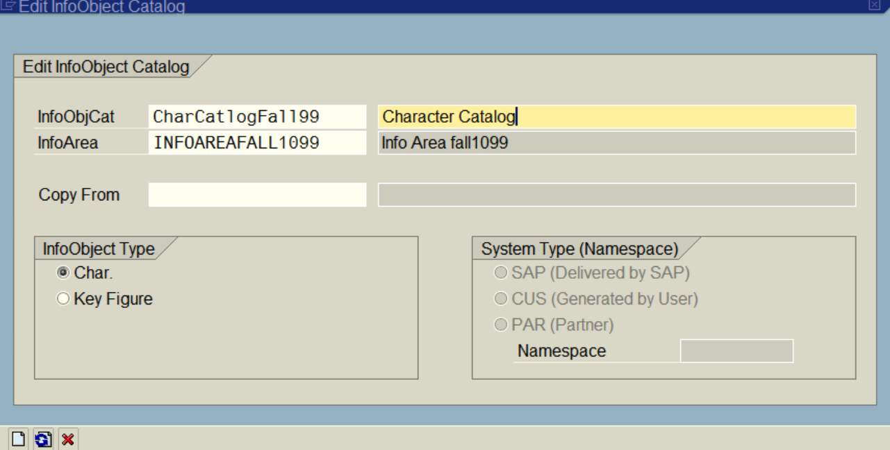

In the new window, click  to activate the InfoObject Catalog.

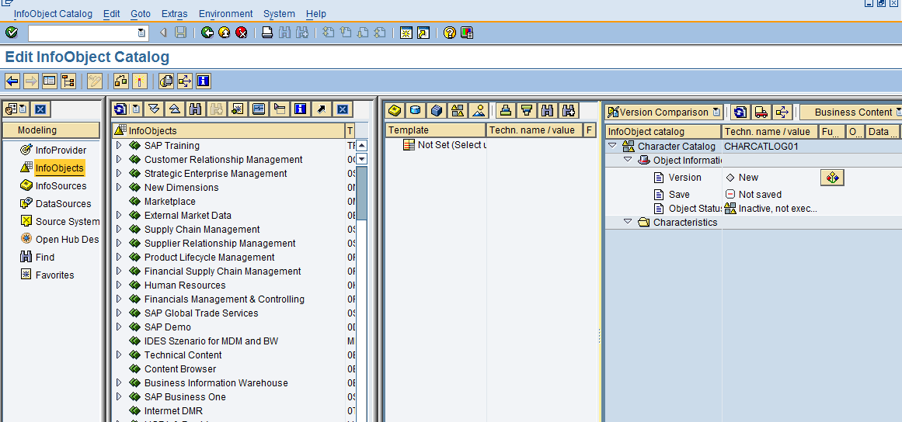

Activate button to be clicked

**Write down the message:**

**Object CHARCATLOGA16046 has been successfully activated**

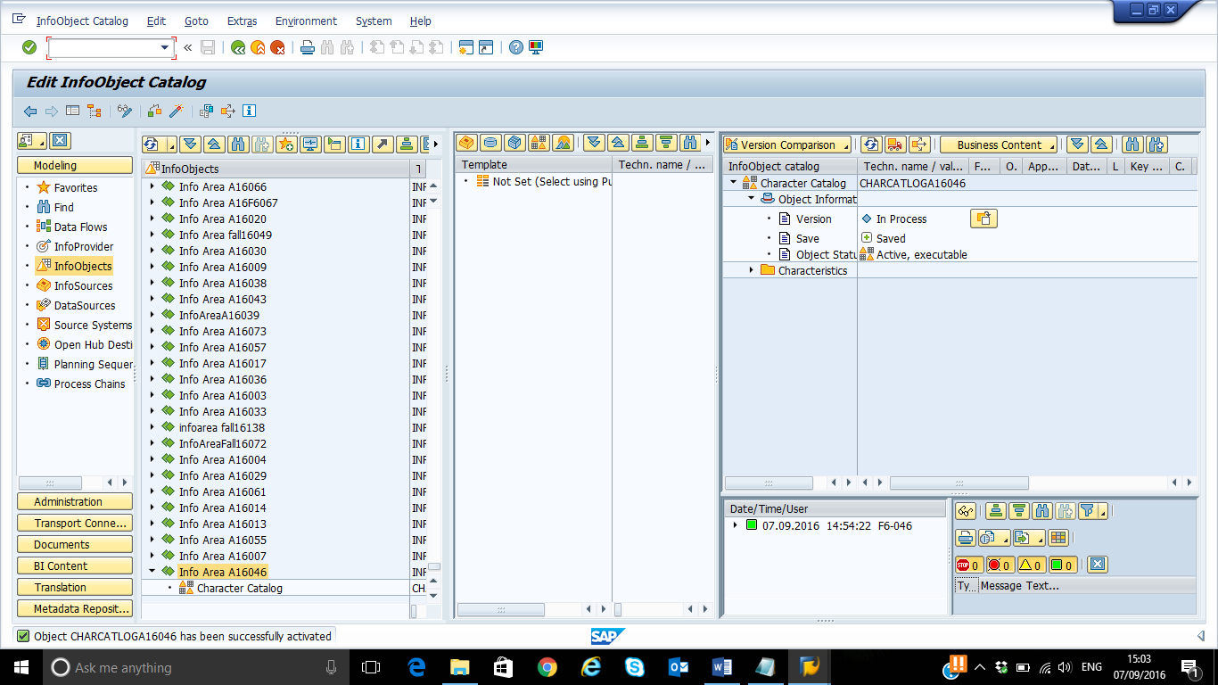

Create an InfoObject Catalog to hold key figures. Right click on the Info Area SMYYXX and select

Create InfoObject catalog.

Step 1: Infoobject Name: KeyCatlogSYYXXX

Step 2: Description: Key Figure Catalog

Step 3: Make sure that the option keyfigure is selected under infoobject type

Step 4: Click on create Button

Step 5: Click Activate 

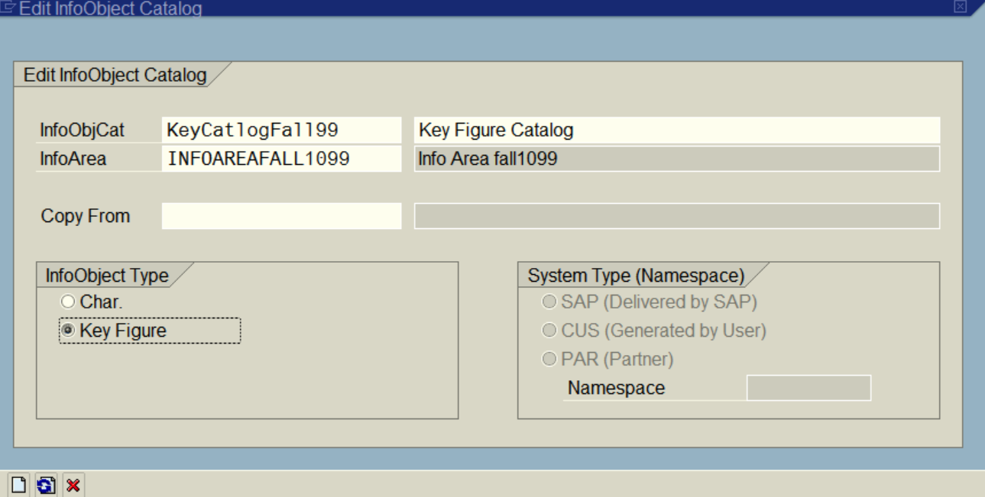

**Write down the message**

**Object KEYCATLOGA16046 has been successfully activated**

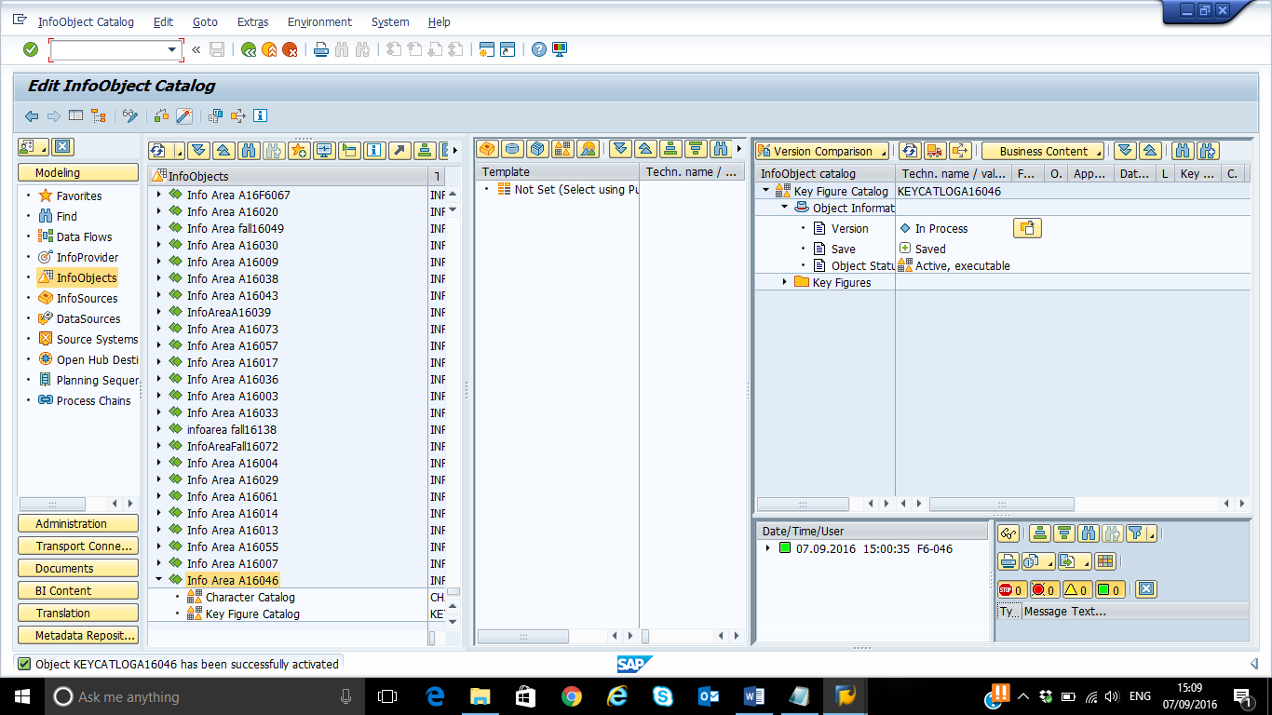

The newly created InfoObject Catalog will be displayed.

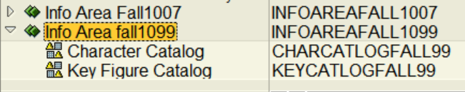

**Create Character Info Object**

Follow the following steps to create other Characteristics listed.

**Note: You may wish to create the Display Attributes first. You will need to identify the display attributes for the primary ID attributes by clicking on the attribute tab in the primary ID creation.**

|  |  |  |  |  |  |  |
| --- | --- | --- | --- | --- | --- | --- |
|  | **Characteristics Name** | **Characteristic Description** | **Assigned**  **To** | **Datatype** | **Length** | **Display**  **Attribute** |
| **1.** | MIDSYYXXX | Material ID |  | CHAR | 15 | NO |
| **Display Attribute of Material ID** | MNMSYYXXX | Material Name | Material ID | CHAR | 30 | YES |
| **2.** | CIDSYYXXX | Customer ID |  | CHAR | 15 | NO |
| **Display Attribute of Customer ID** | CNMSYYXXX | Customer Name | Customer ID | CHAR | 40 | YES |
| **Display Attribute of Customer ID** | CADSYYXXX | Customer Address | Customer ID | CHAR | 60 | YES |
| **3.** | SRDSYYXXX | Sales Representative ID |  | CHAR | 15 | NO |
| **Display Attribute of Sales Representative ID** | SNMSYYXXX | Sales Representative Name | Sales Rep ID | CHAR | 40 | YES |

Right Click on the Character Catalog Created, then select create InfoObject

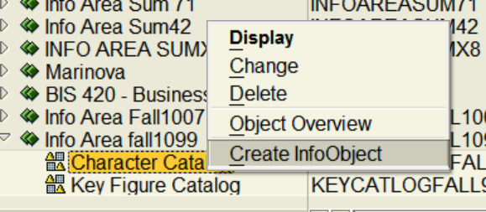

Enter the Name: **CIDSYYXXX** and description: **Customer ID** and then click enter, to continue.

Note: the character name should be between 3 and 9 character length.

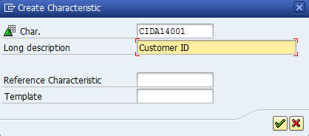

Select the data type: **CHAR** and specify the length- **15**. **Check and Activate** Customer ID InfoObject.

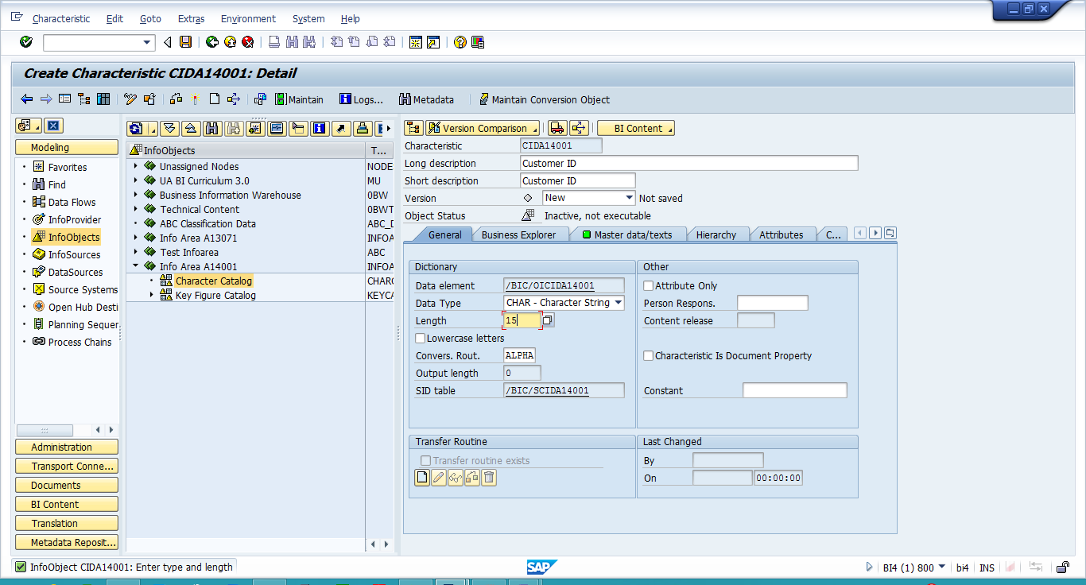

You will see the Customer ID InfoObject created under the character catalog.

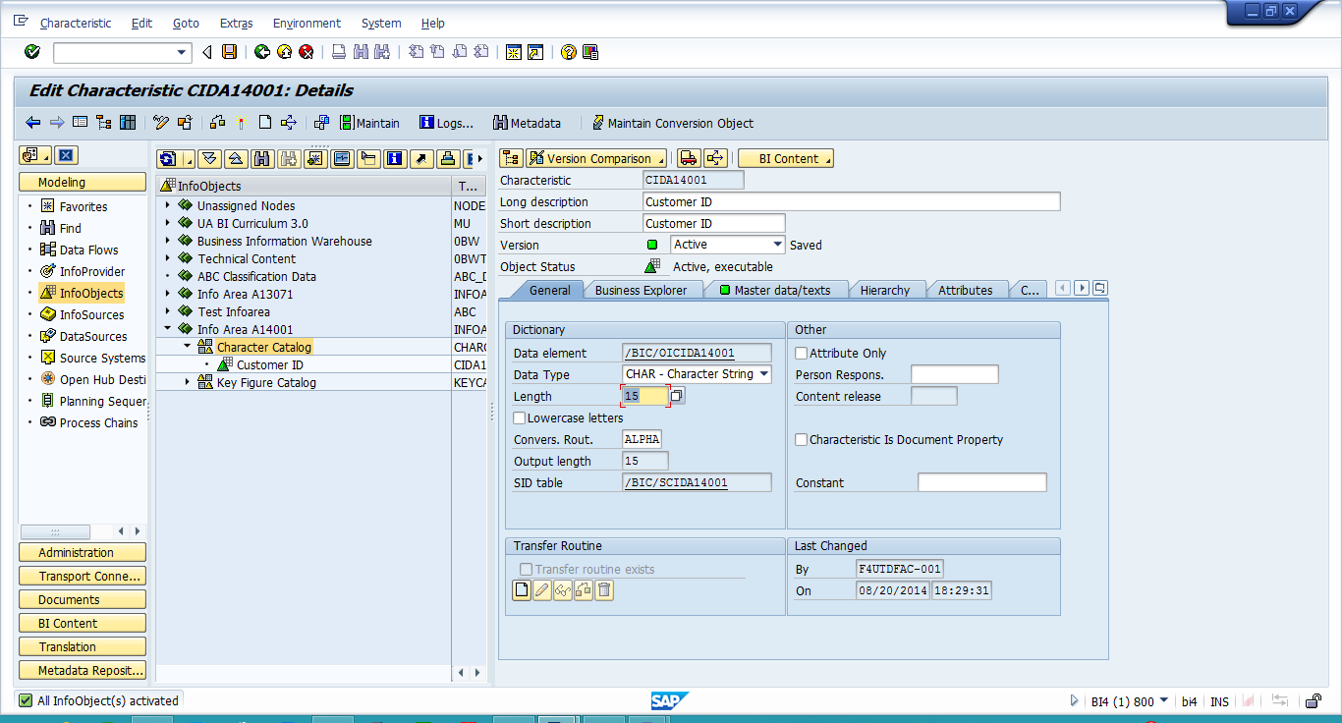

**Screenshot: Customer ID InfoObject created under the character catalog.**

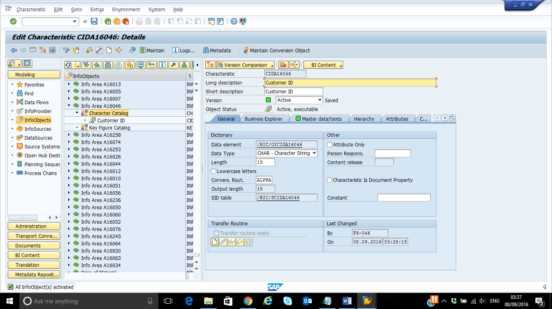

Right Click on the Character Catalog to create Customer Name InfoObject. Enter the Name: **CNMSYYXXX** and description: **Customer Name** and then click enter, to continue.

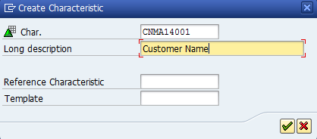

In the General tab, choose data type as "Character String" and enter 40 as length. **Make sure to "Check" the "Attribute Only" check box.**

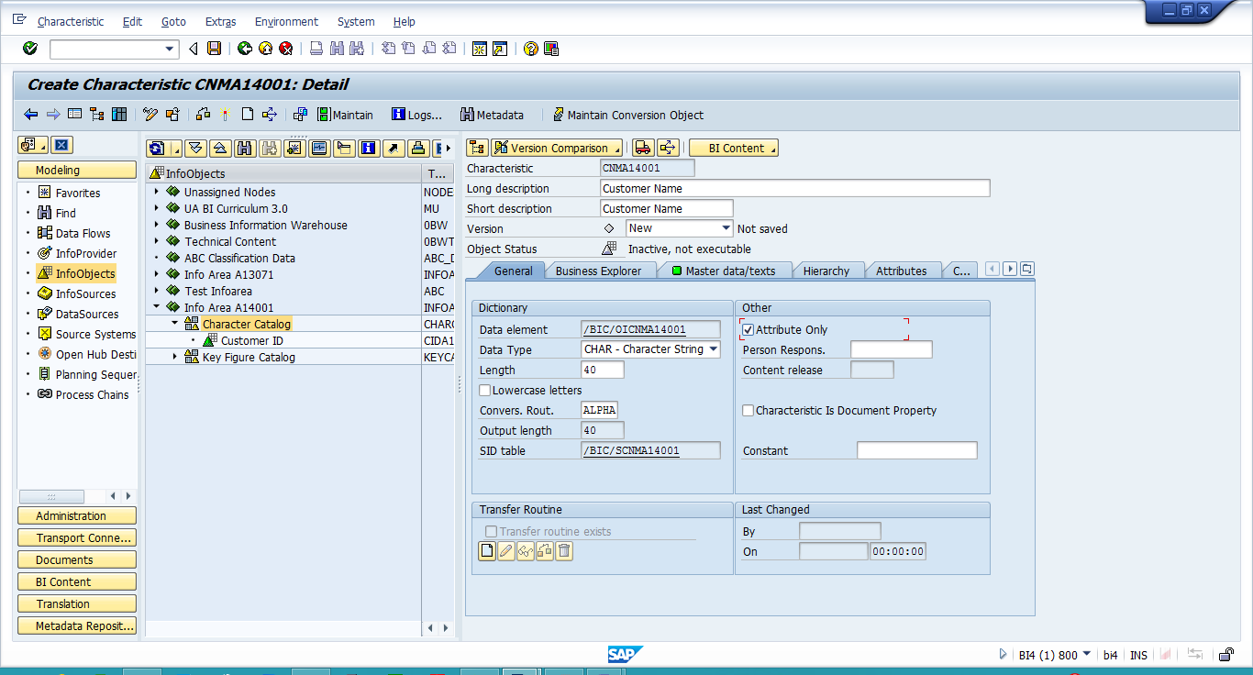

**Check and Activate** Customer Name InfoObject.

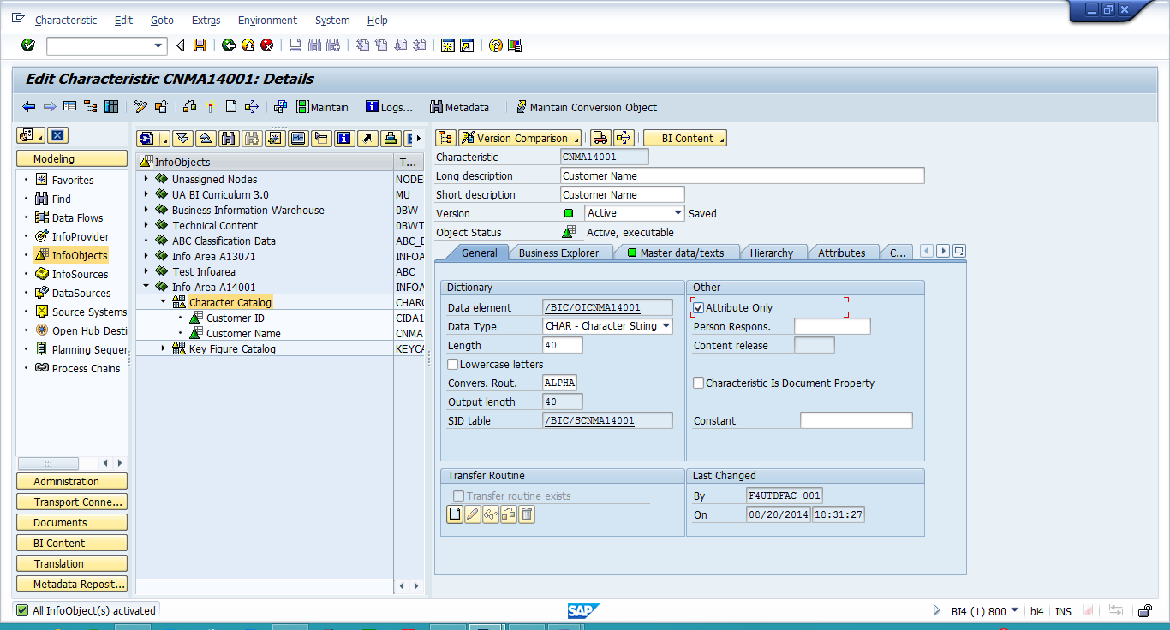

You will see the Customer Name InfoObject created under the character catalog.

**Screenshot: Customer Name InfoObject created under the character catalog**

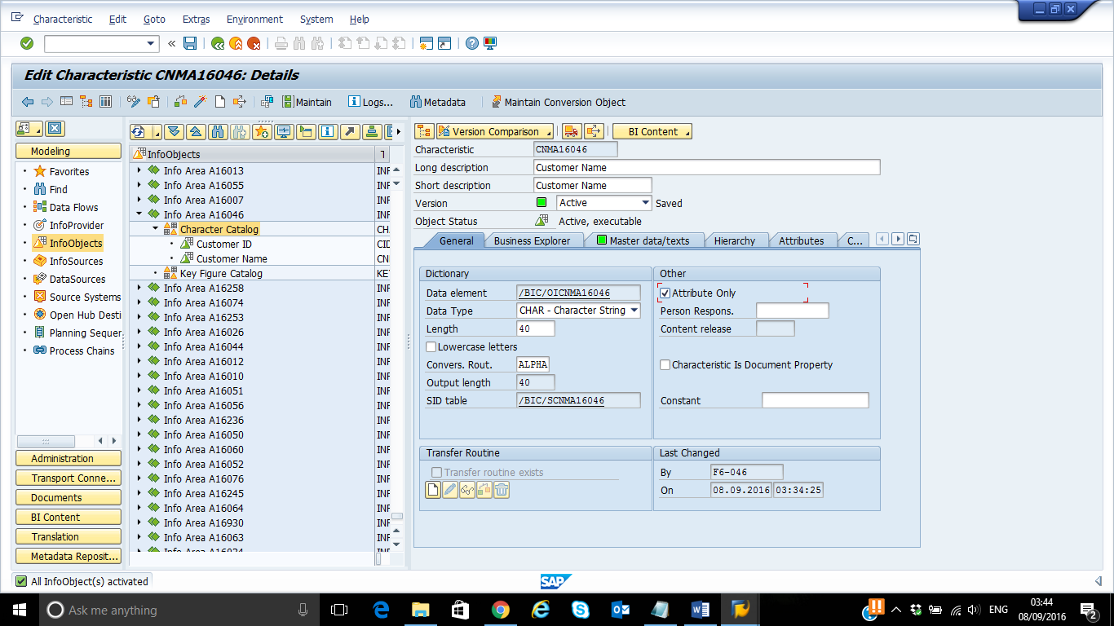

Right Click on the Character Catalog to create Customer Address InfoObject. Enter the Name: CADSYYXXX and description: **Customer Address** and then click enter, to continue.

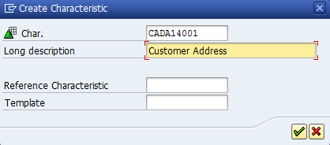

In the General tab, choose data type as "Character String" and enter 60 as length. **Make sure to "Check" the "Attribute Only" check box.**

**Note**: If Attribute only is selected, the attribute can be used only as a display attribute, not as a navigational attribute.

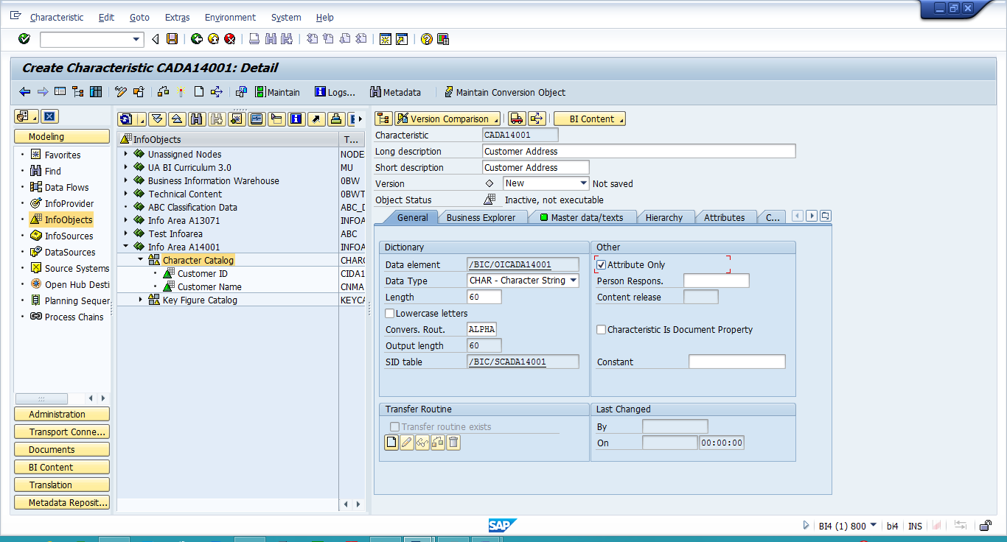

**Check and Activate** Customer Address InfoObject.

You will see the Customer Address InfoObject created under the character catalog.

**Screenshot: Customer Address InfoObject created under the character catalog**

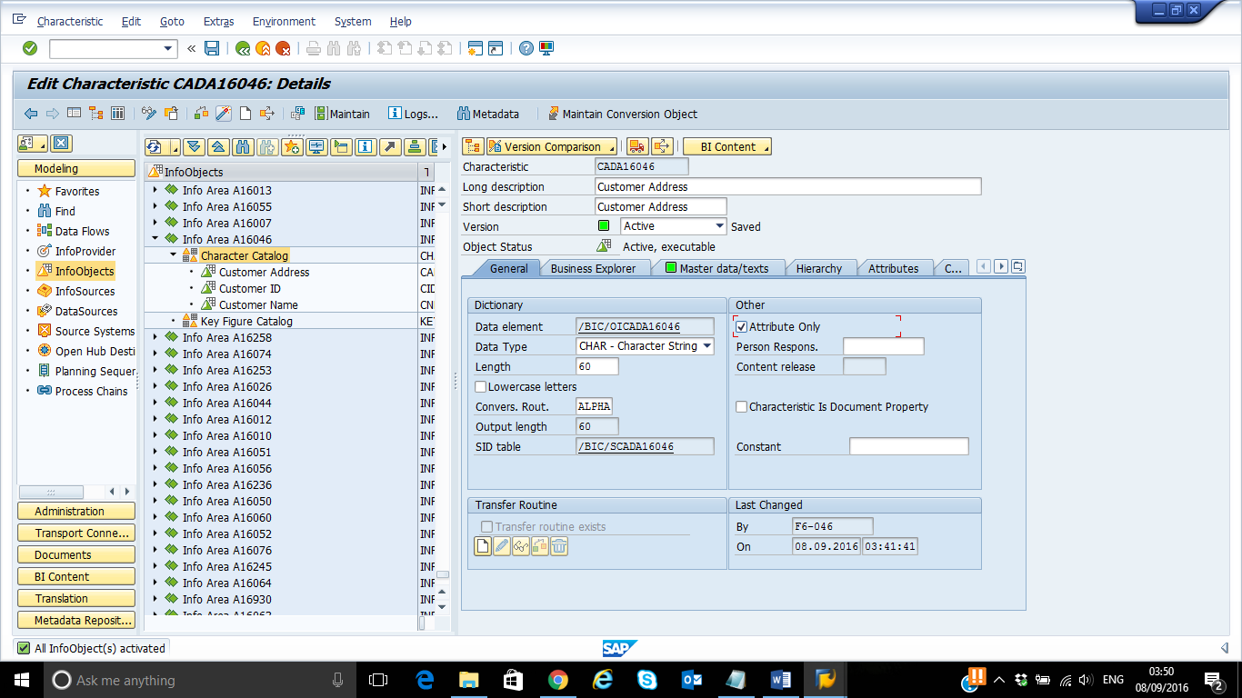

Click on the CustomerID InfoObject and change it into "edit" mode by pressing the Display <-> change button or by pressing ctrl+F1

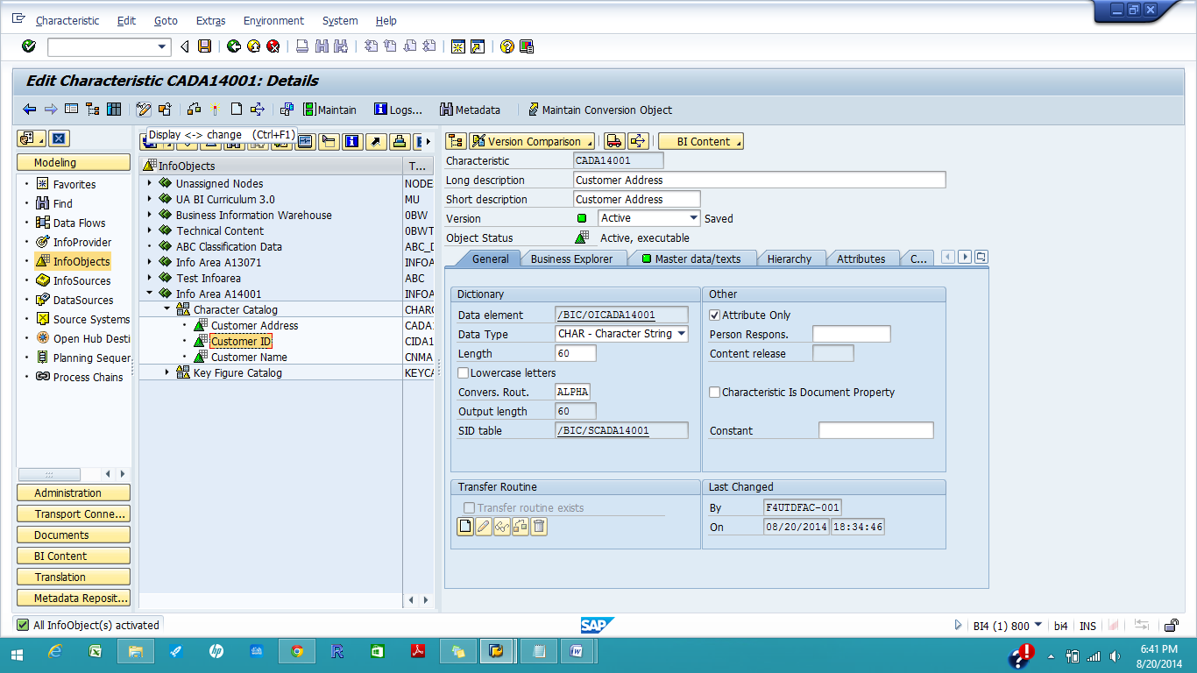

Click on the Attributes tab and give the technical names of the attributes(Customer Name-CNMSYYXXX and Customer Address- CADSYYXXX) created in the last step. Click on the **Save** button. Check and **activate** the InfoObject.

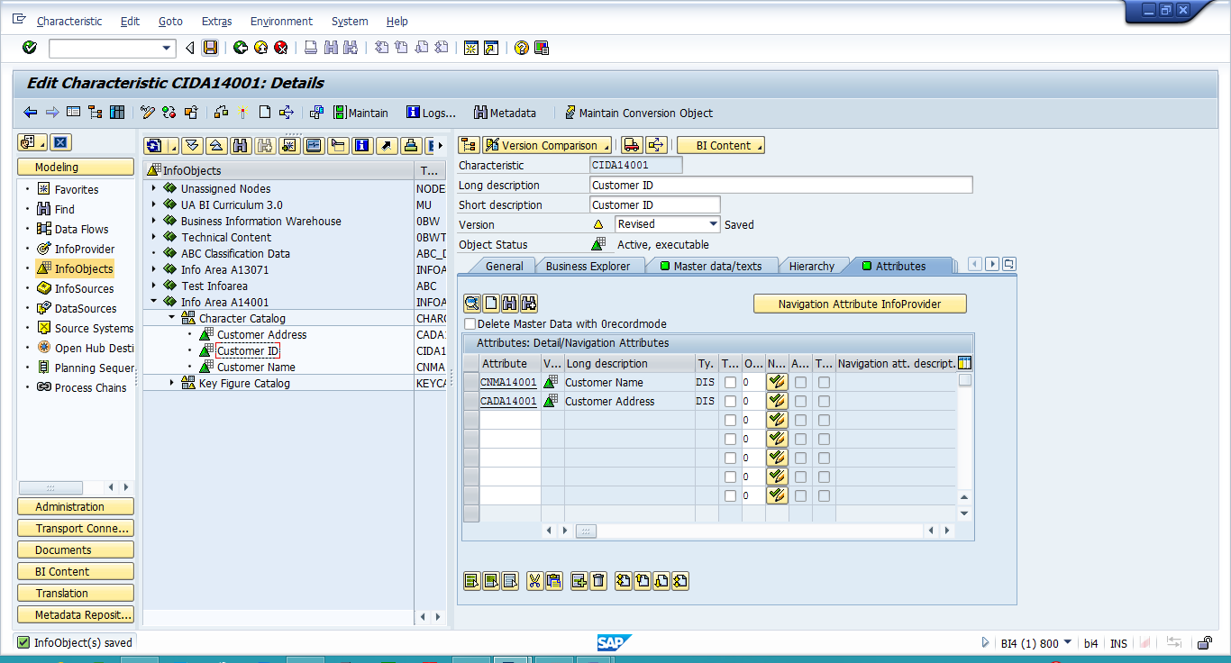

**Screenshot:**

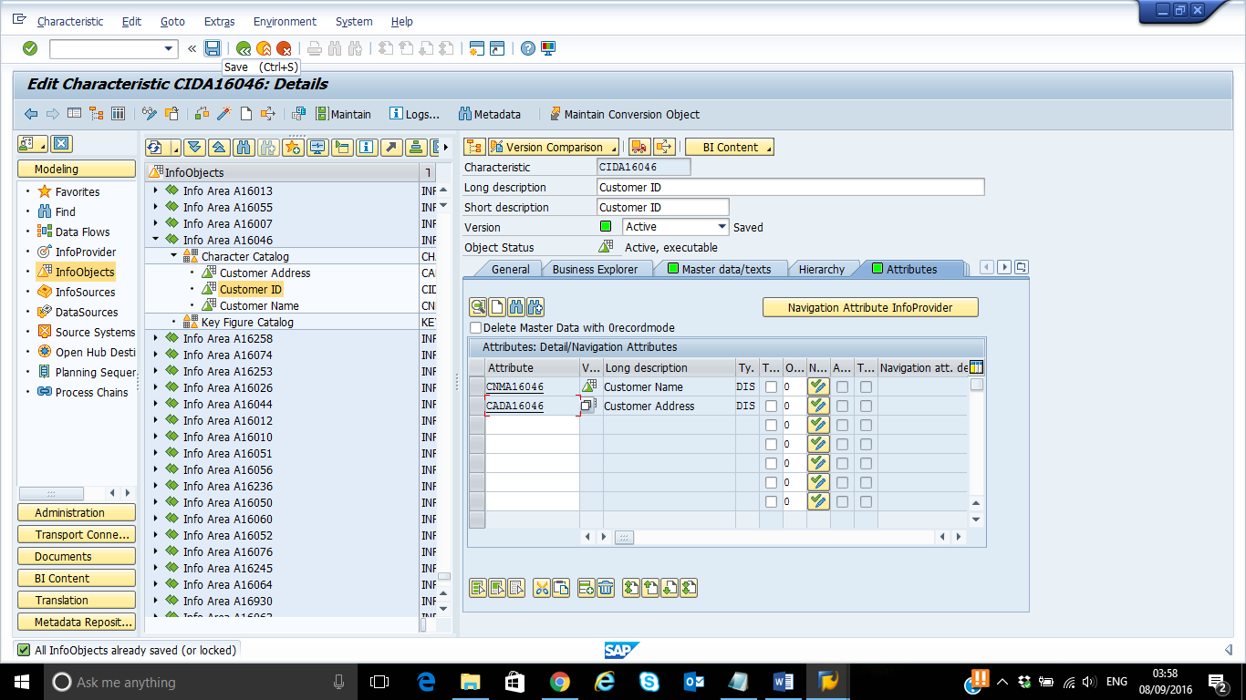

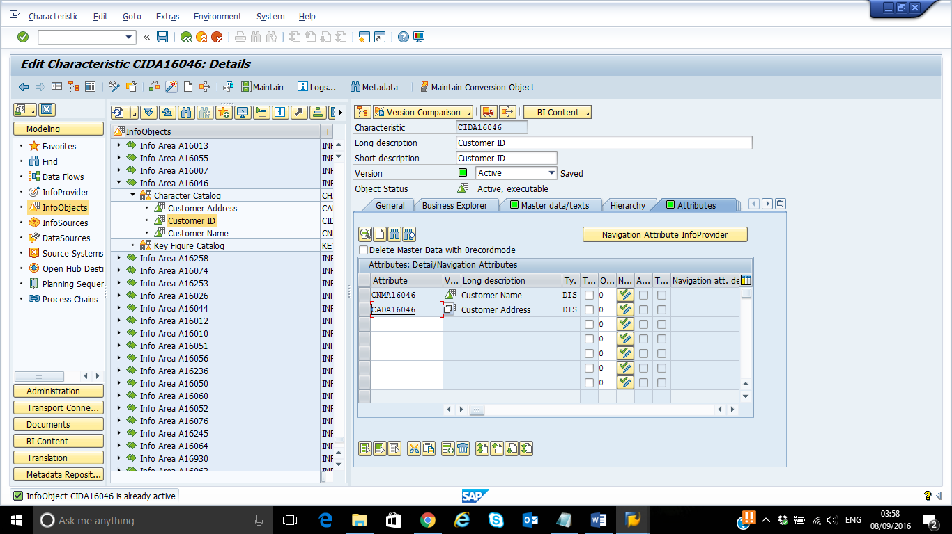

Repeat the above steps for creating the remaining objects in the table

* Material ID and its attributes (Material Name)
* Sales Representative ID and its attributes (Sales Representative Name)

**Paste the screen shot of all created Info Objects after creating each characteristic.**

Material ID:

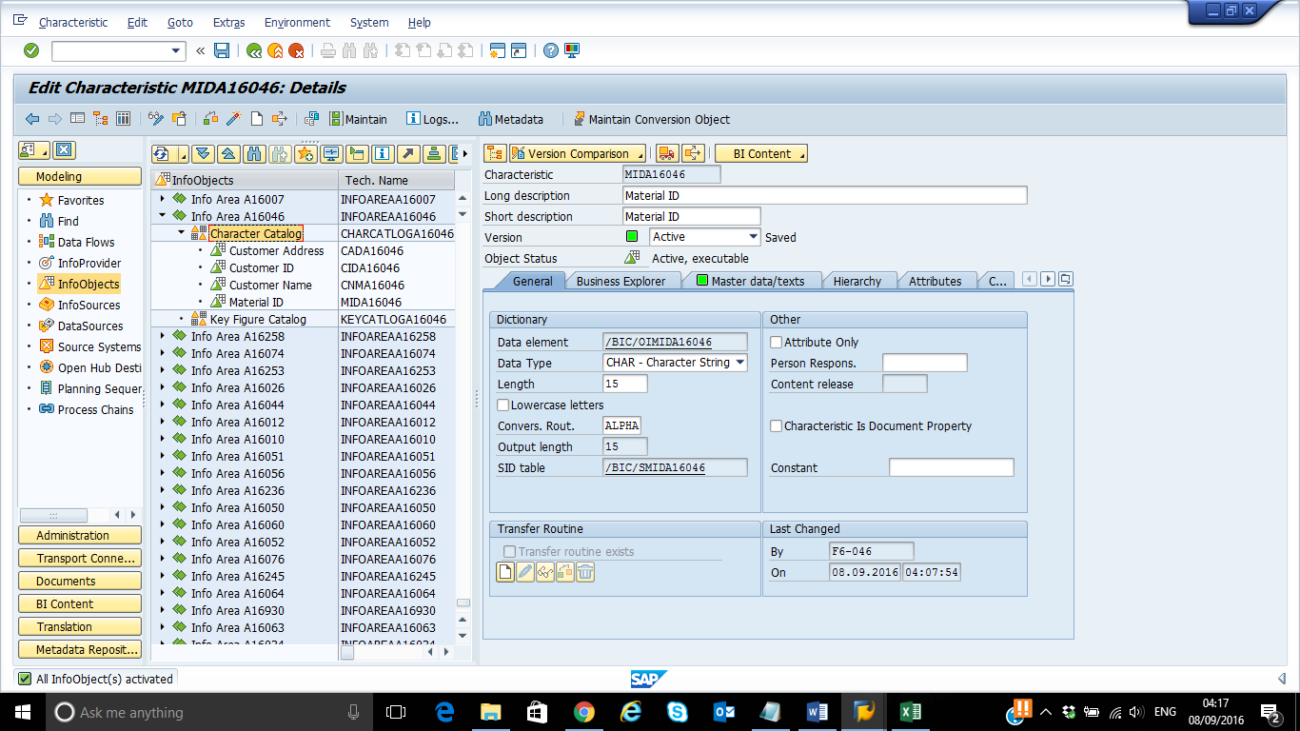

Material Name:

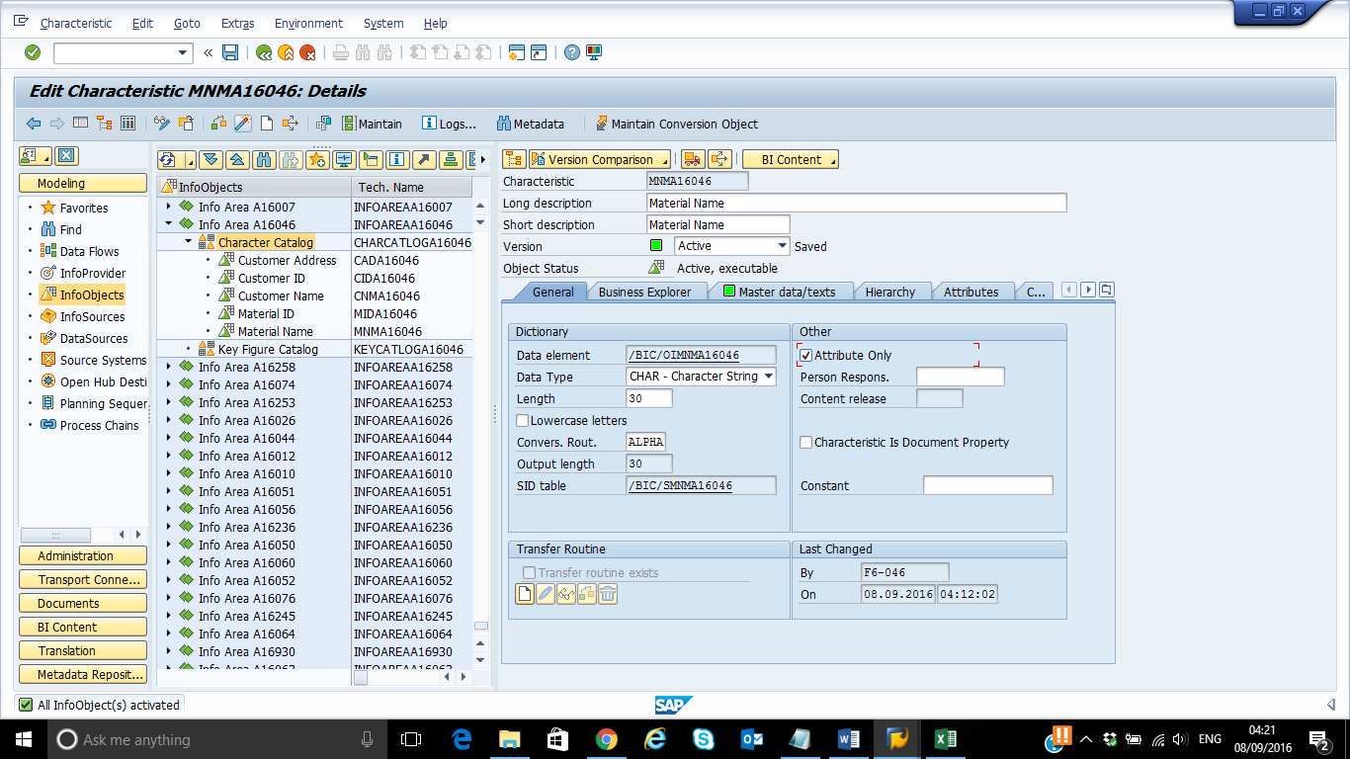

Screenshot: Added the technical name for attribute Material Name to Material ID:

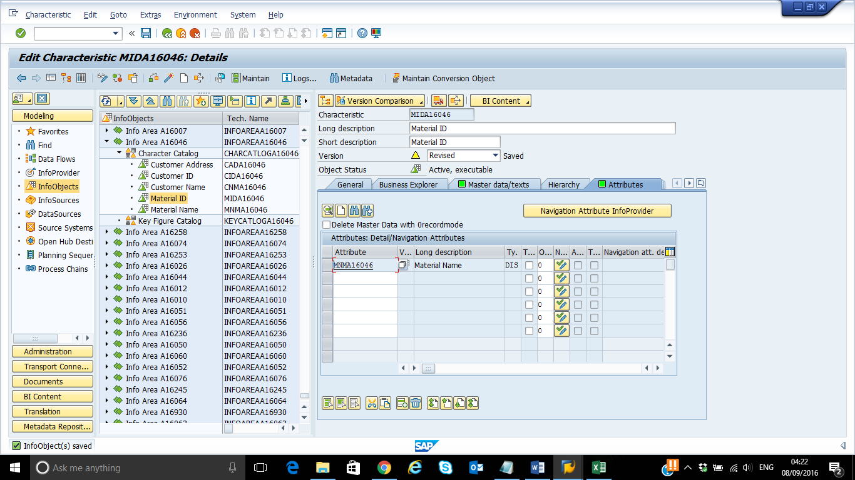

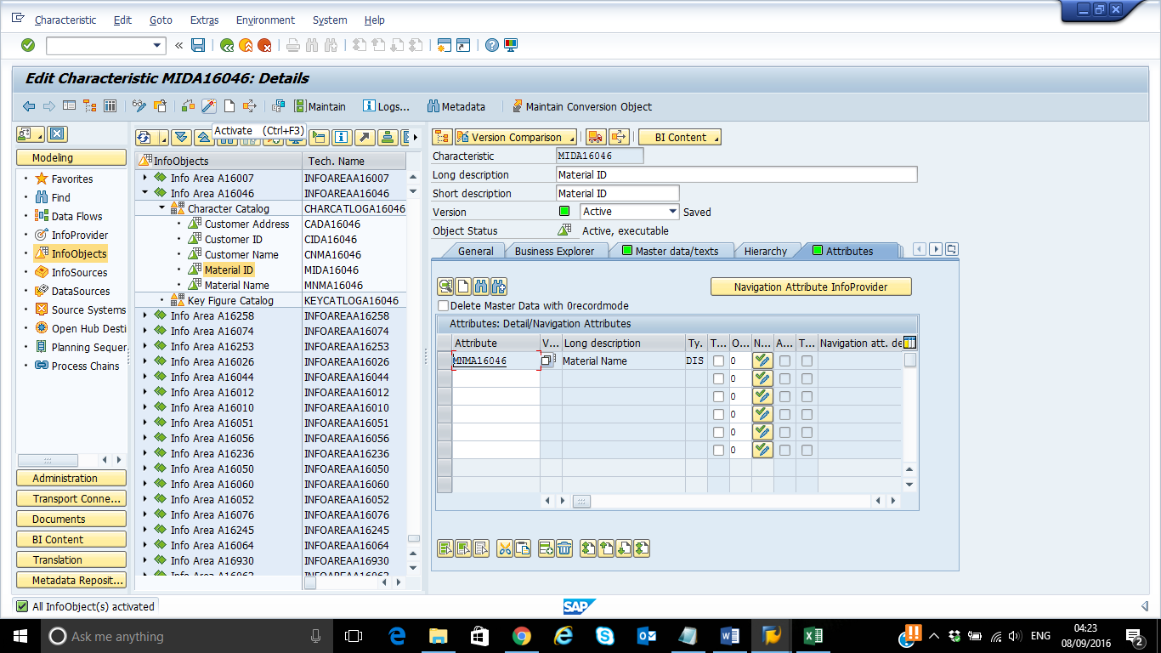

Sales Representative ID:

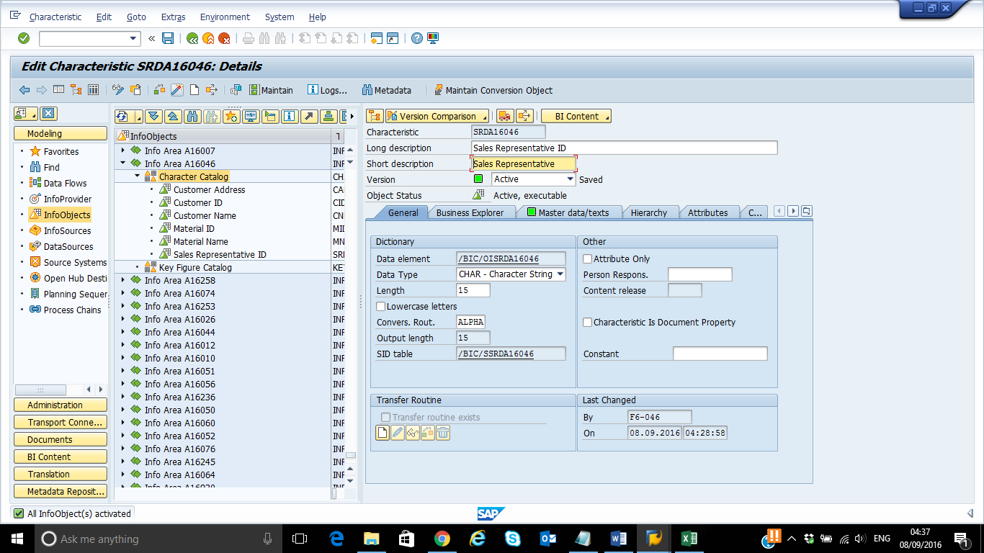

Sales Representative Name:

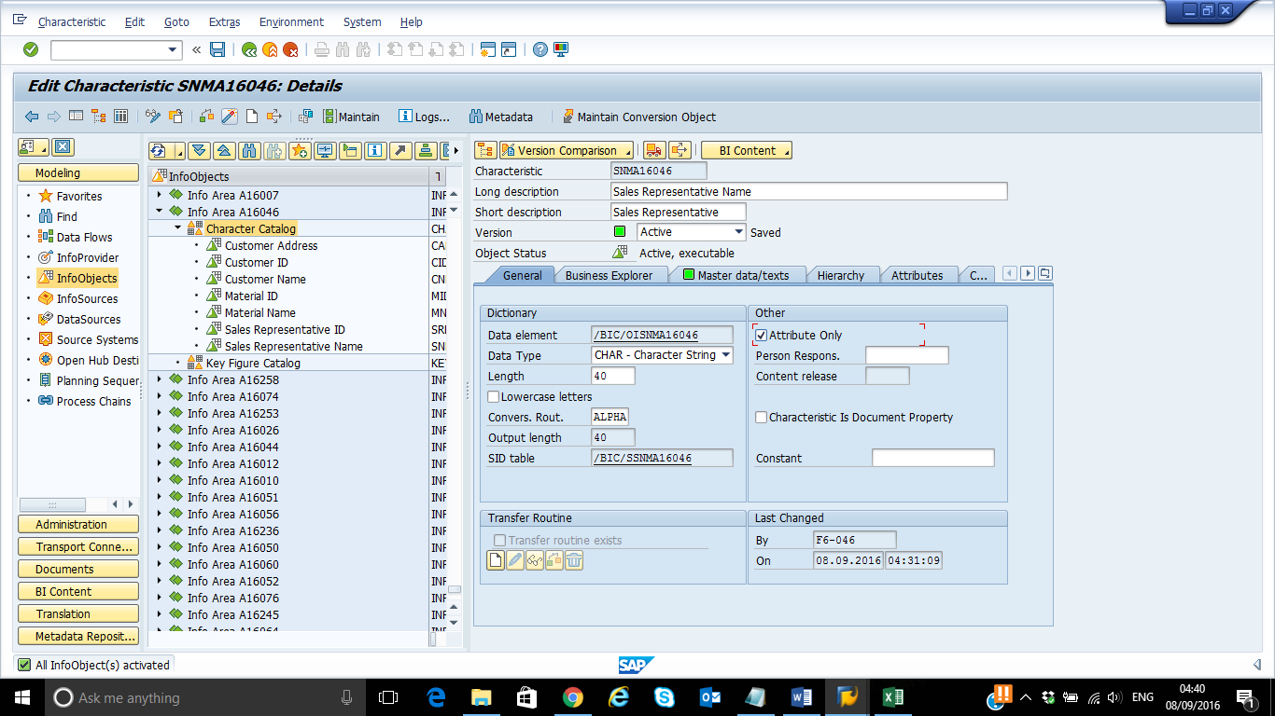

Screenshot: Added the technical name for attribute Sales Representative Name to Sales Representative ID:

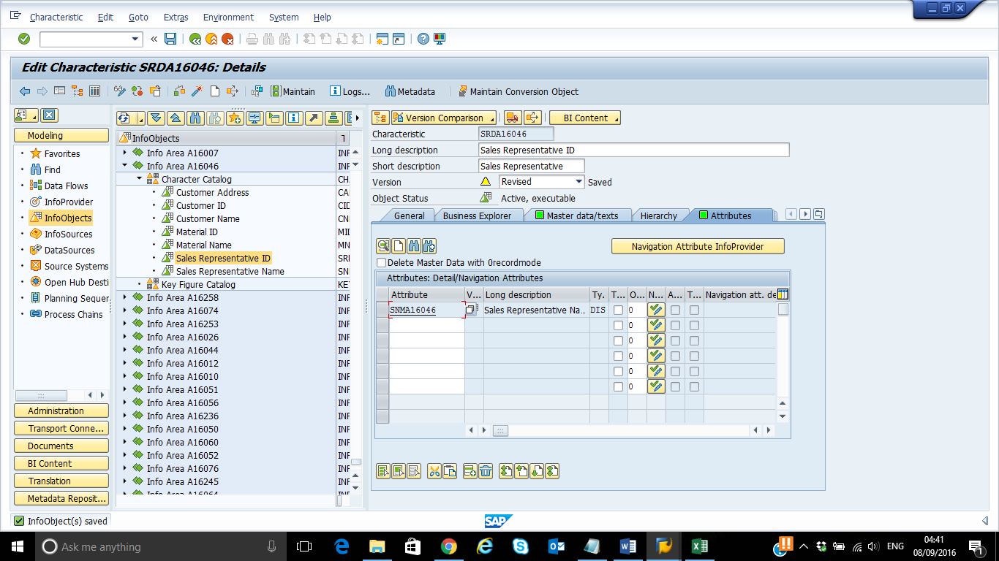

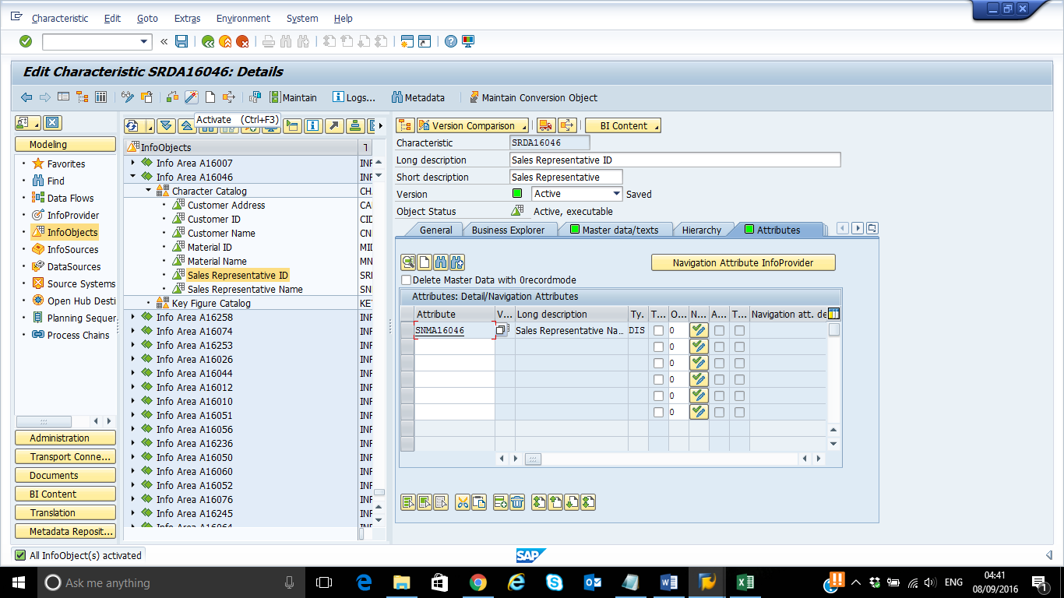

**Create Key Figure**

Create the Following Key Figures:

|  |  |  |
| --- | --- | --- |
| **Key Figure Name and Description** | **Type/Data type** | **Currency/ Unit of Measure** |
| PRSYYXXX/ Price of Material | Amount | Fixed Currency: USD |
| QTSYYXXX/ Sales Quantity | Quantity | Unit/ Currency: 0UNIT (Unit of Measure) |
| REVSYYXXX/ Sales Revenue | Amount | Fixed Currency: USD |

Right click on Key Figure Catalog and select Create InfoObject.

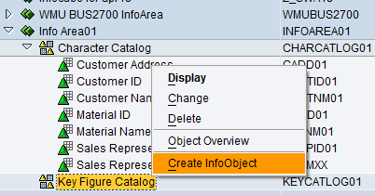

Enter a name: **PRSYYXXX** and a description: Price of Material, and then click to continue.

Note: The name should be between 3 to 9 Character Length.

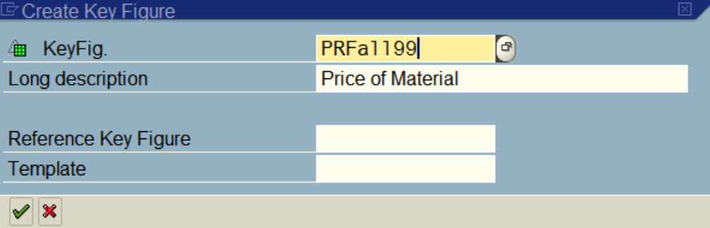

Select **Amount** in the block Type/data type, select USD as the Fixed currency in the block Currency/unit

of measure, and then click to check the key figure. If it is valid, click to activate the key figure.

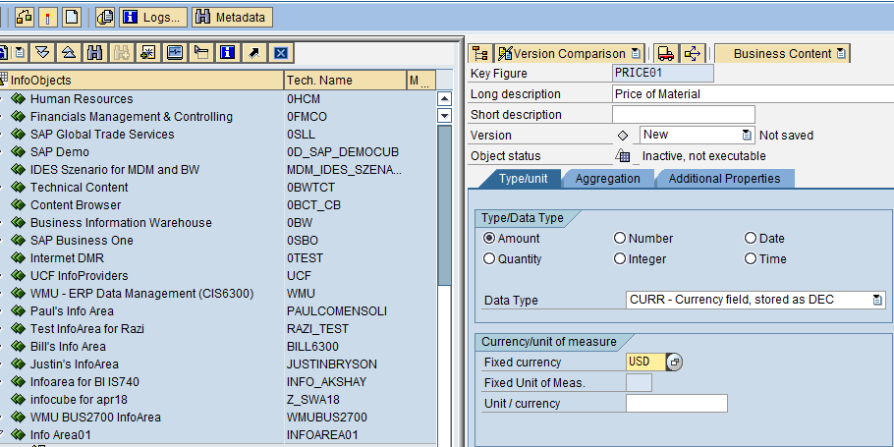

Screenshots: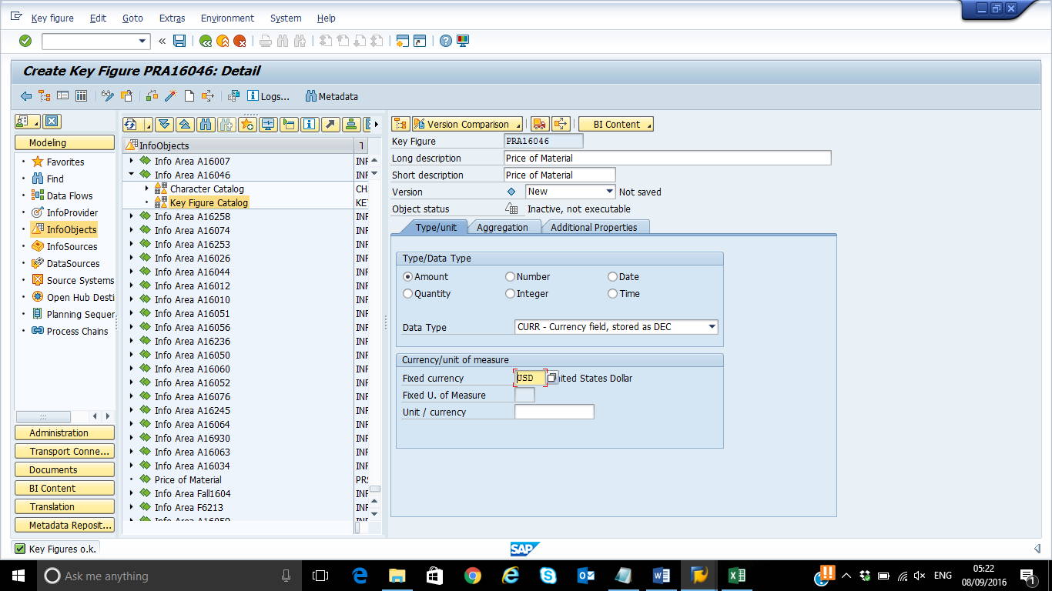

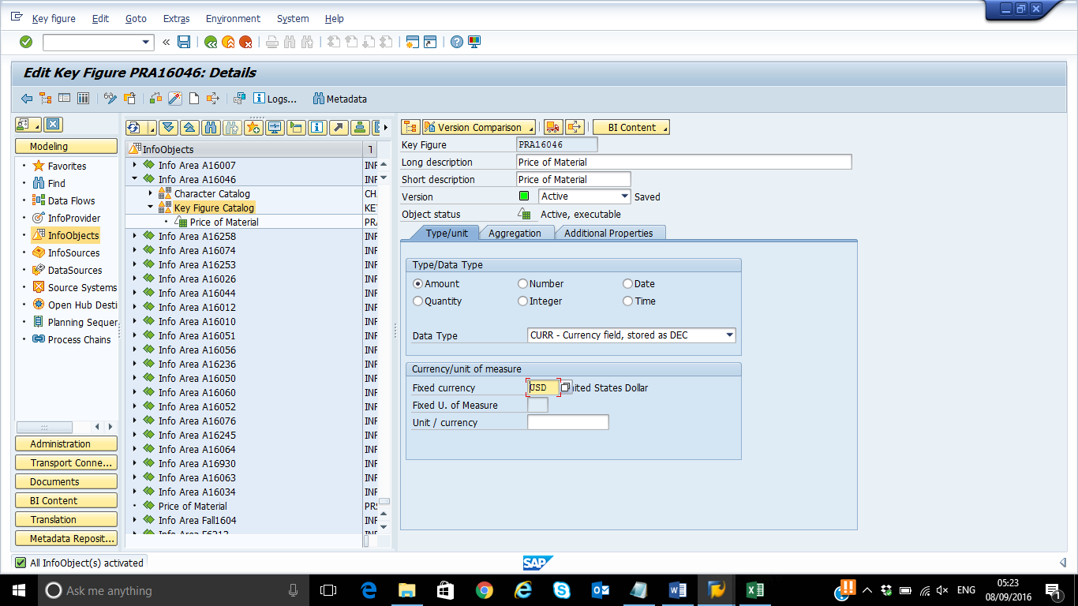

Follow the above steps to create the remaining 2 Key Figures mentioned in the table.

**After creating each Key Figure paste, a similar screenshot of all the Info Objects created.**

**Screenshot: Sales Quantity:**

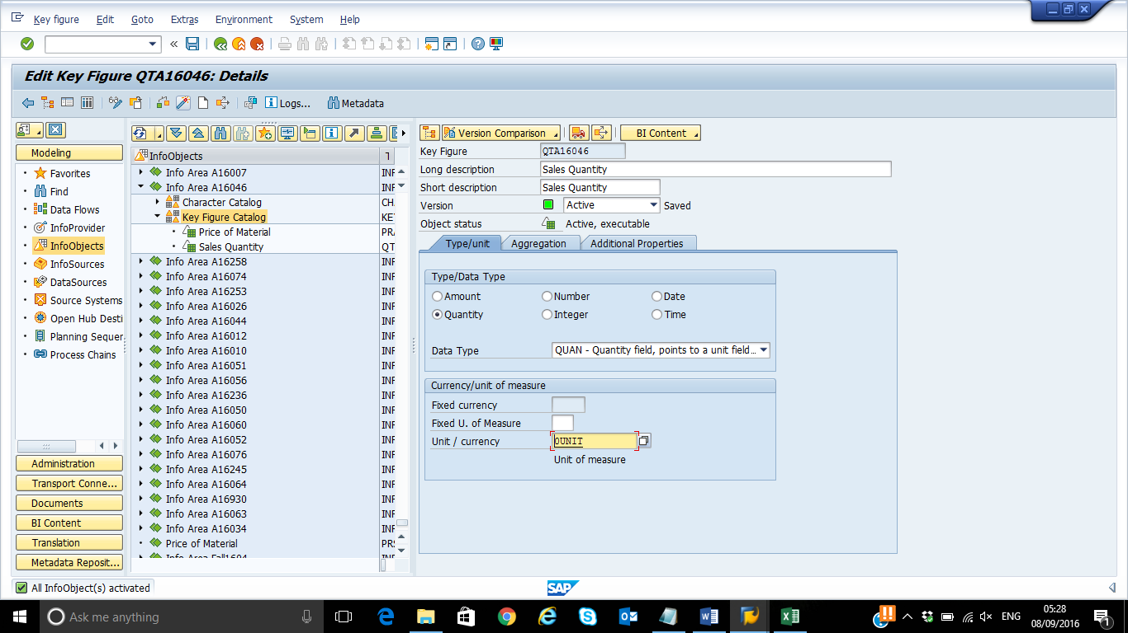

**Screenshot: Sales Revenue**

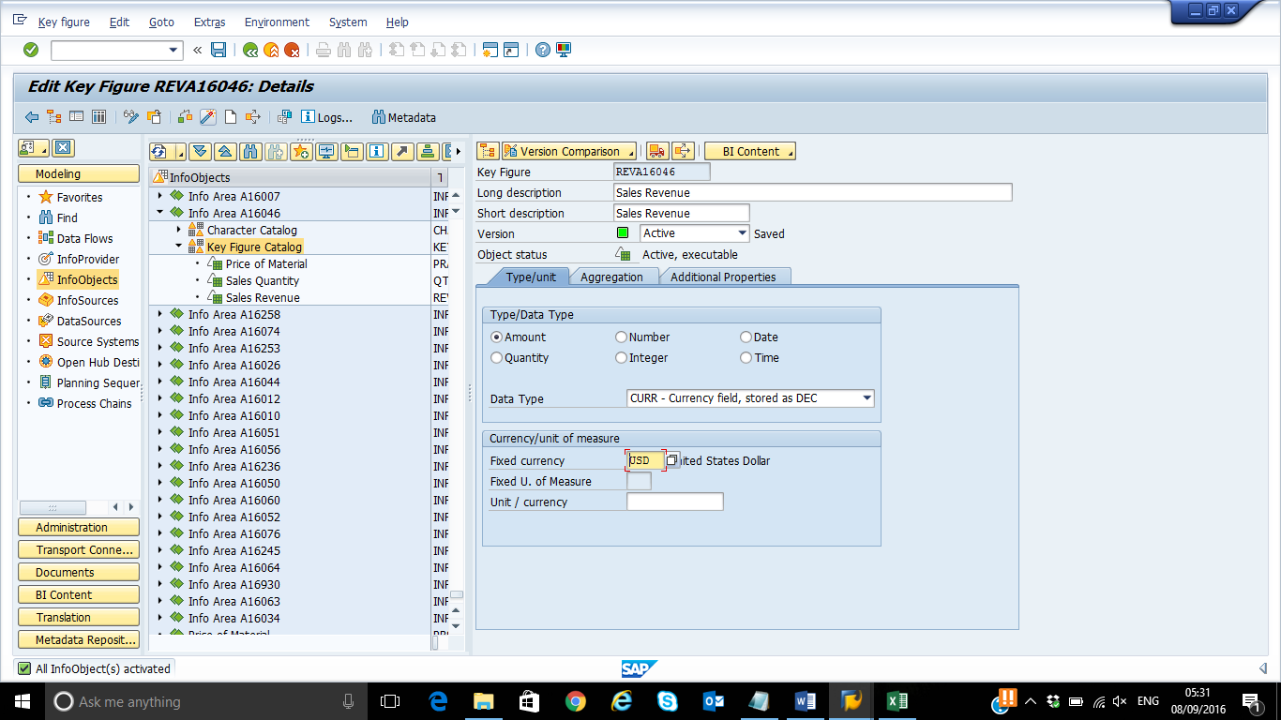

**PART 2**

**Objective**

This part is designed to help students acquire the ability to

* Create DSO
* Create Source system
* Create an application component
* Create DataSource
* Create InfoPackage and load data into PSA
* Create Transformation to DSO
* Create and start Data Transfer Process to DSO
* Activate data in DSO

**Note: Please use DSO Data.csv file for loading data into DSO.**

Run Transaction RSA1 in the command field of your SAP System



OR

Double click on Administrator Workbench. i.e. SAP menu-> Modeling-> RSA1 - Administrator Workbench: Modeling



Click InfoProvider under Modeling in the left panel.

**Creating DSO**

Right click your InfoArea (**InfoAreaSYYXXX**), click on “Create DataStore Object” option. Enter the technical name as DSSYYXXX and description UTDSYY DataStoreObjectXXX.

Click on “Create” icon. You will see the Edit DataStore Object screen.

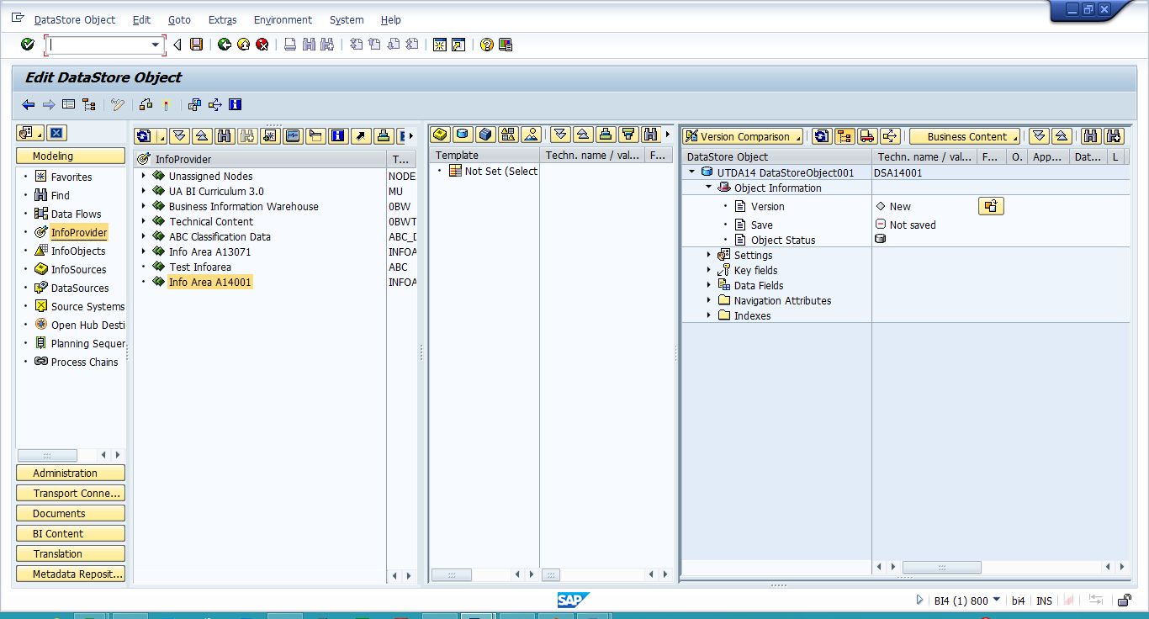

Click InfoObject Catalog icon.

Note: If you do not see your InfoObject Catalogs created in the previous exercise**,** click the icon in the top right to show all InfoObject Catalogs. Then use the binoculars to search for your Characteristic InfoObject Catalog. Once it appears, double click it.

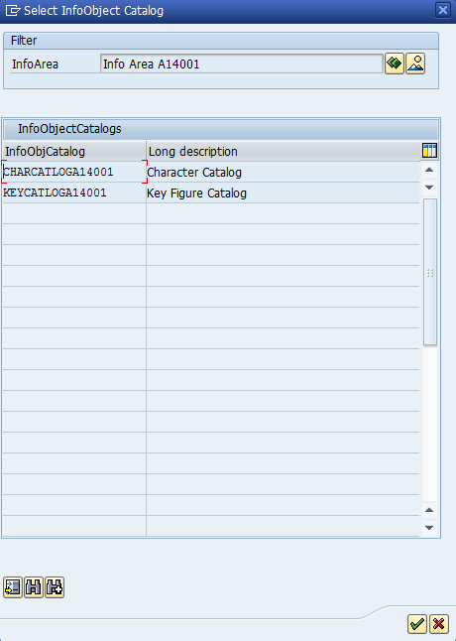

Double click your Characteristic InfoObject Catalog.

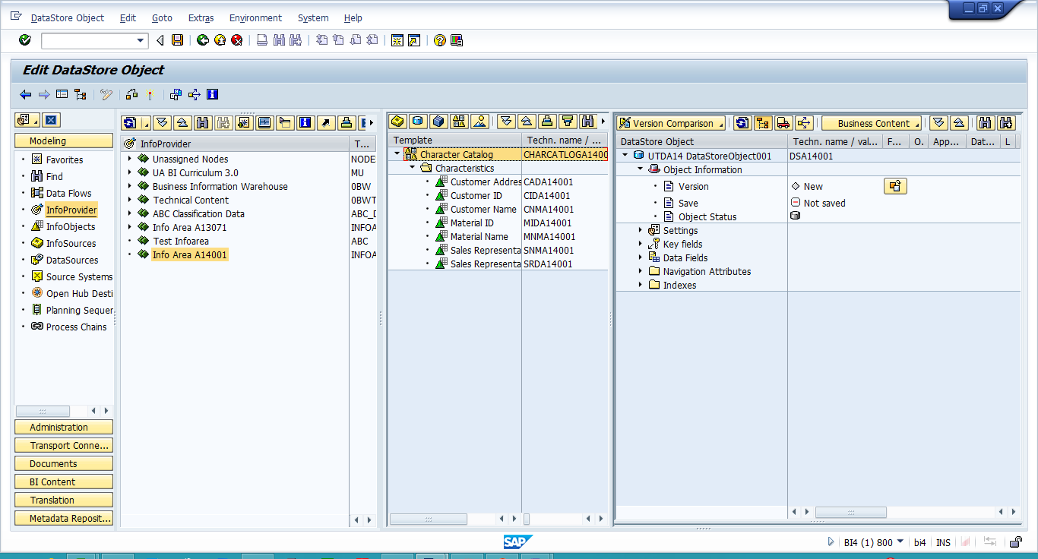

Drag all the characteristics to the DataStore Object **key fields.**

Note: Another way to do this is to right click the characteristic and choose “copy” then click on “key fields” of the DSO -> insert

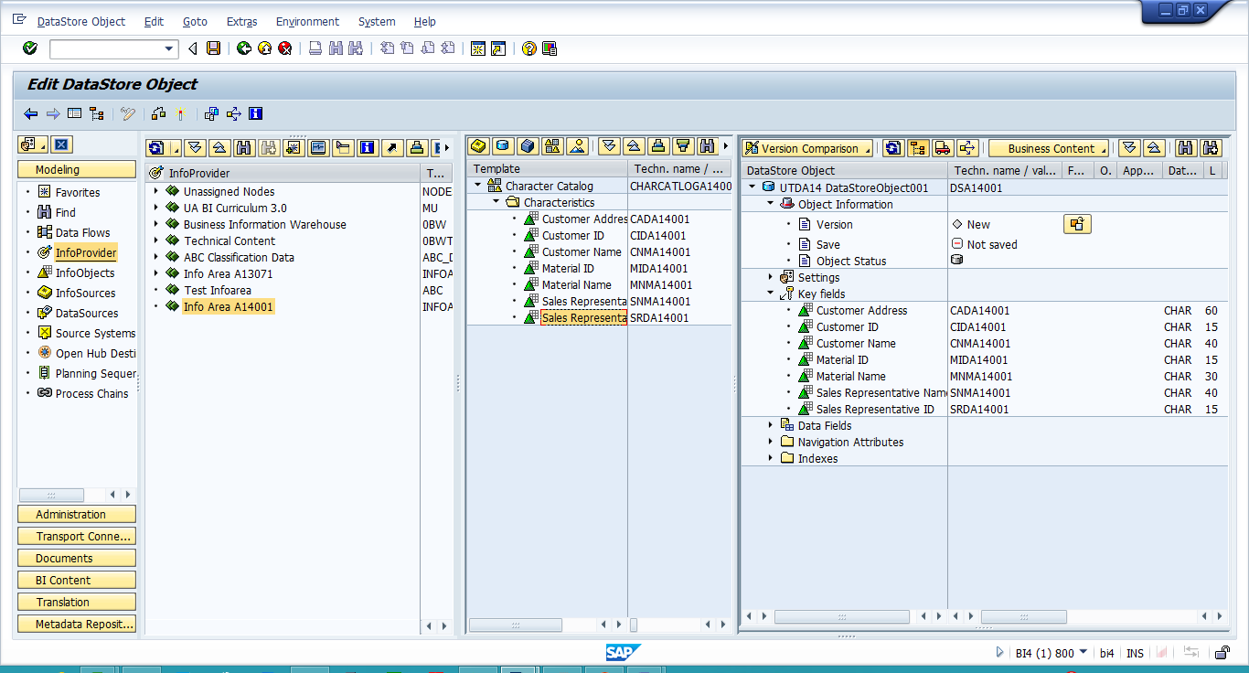

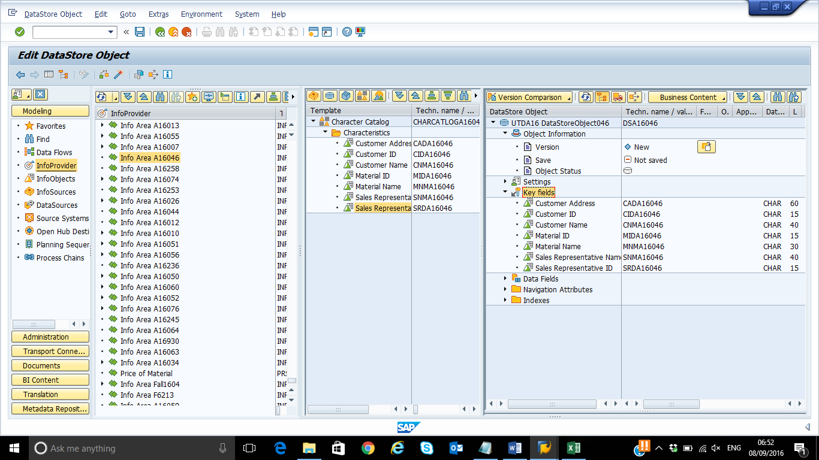

Repeat the process using your Key Figures Catalog to add your Key Figures to **Data Fields** of the DSO.

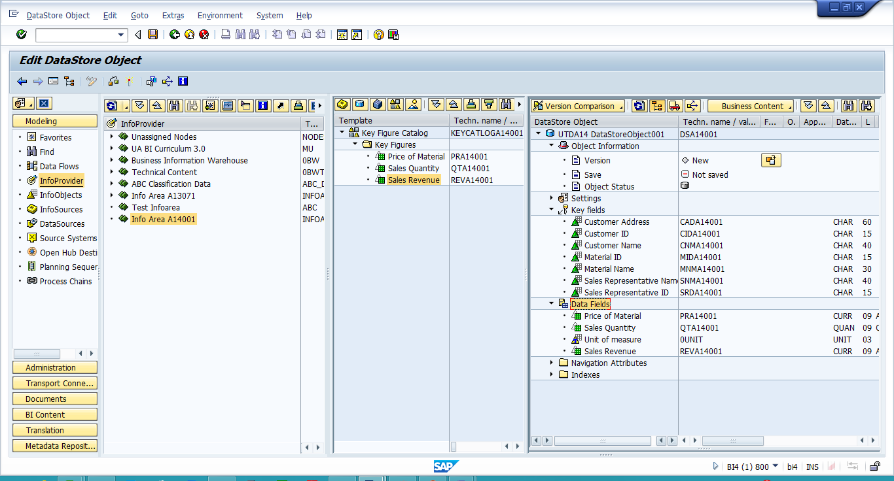

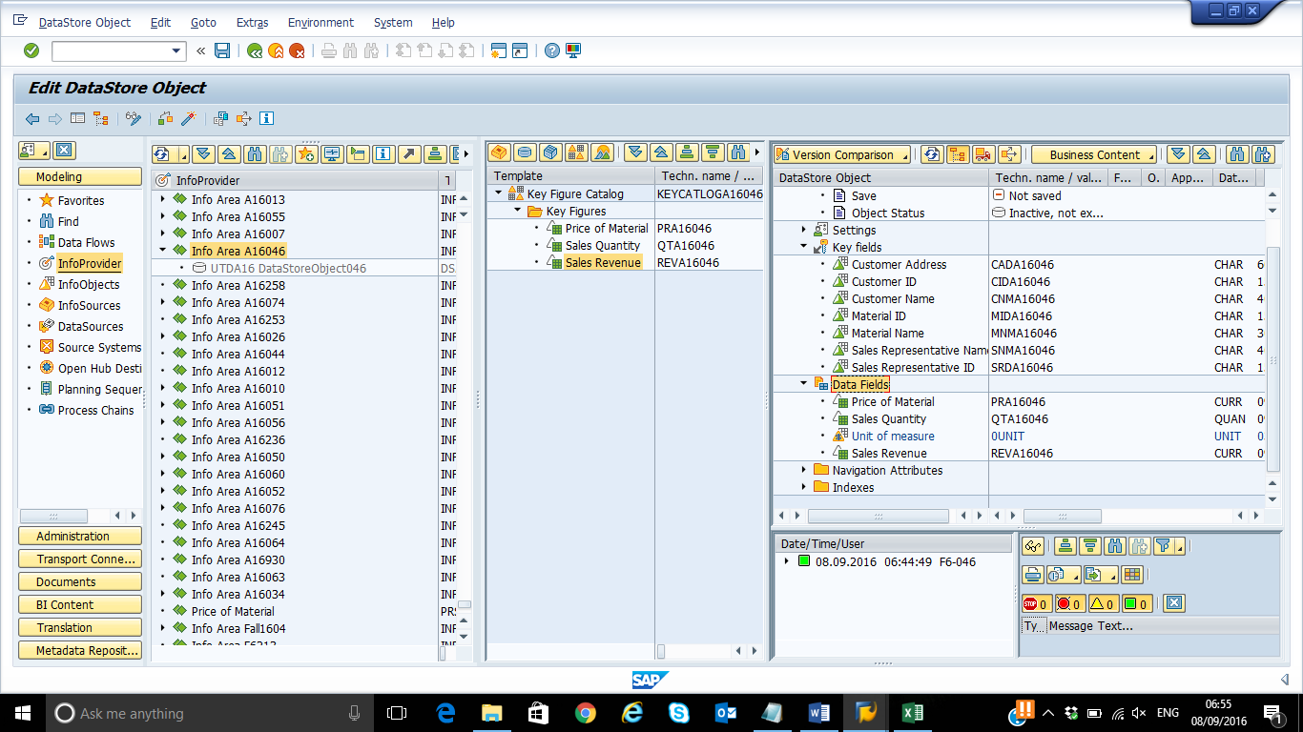

Right click the Key Fields and choose InfoObject Direct Input to add 0CALDAY.

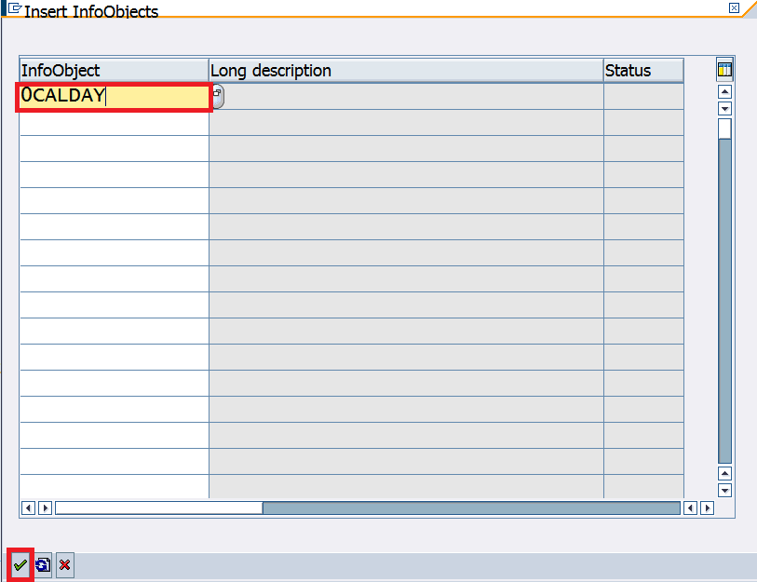

Your DSO should Look like below:

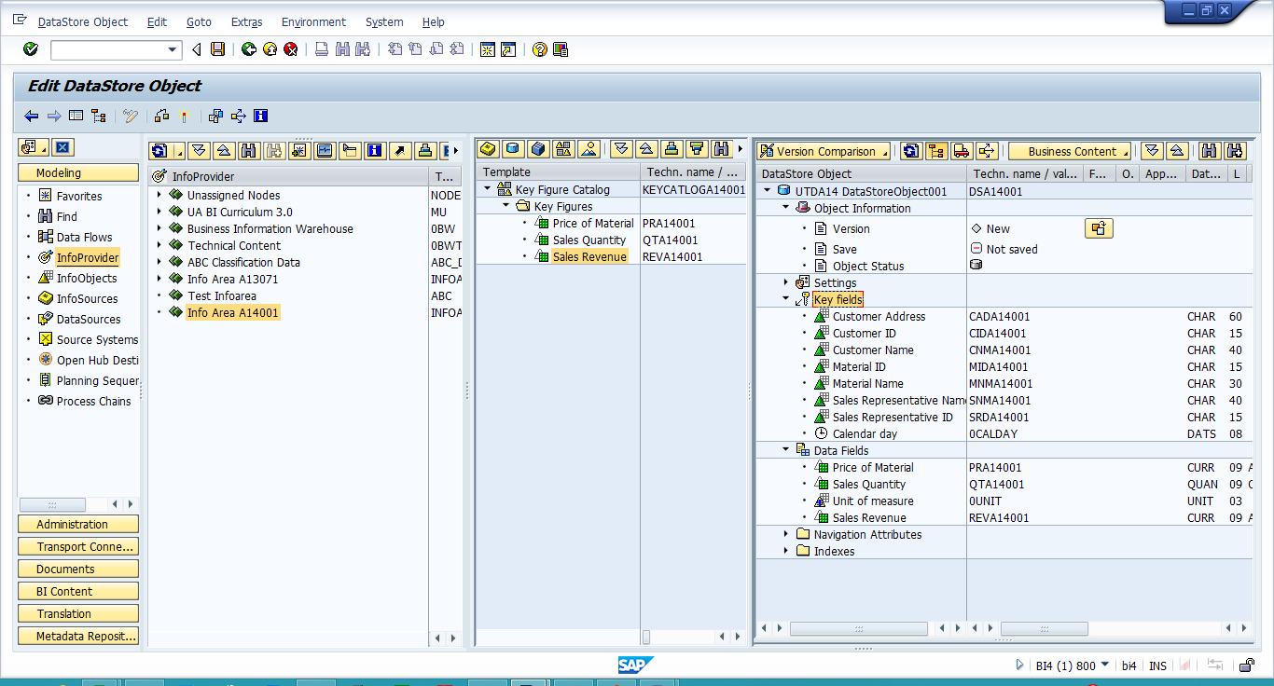

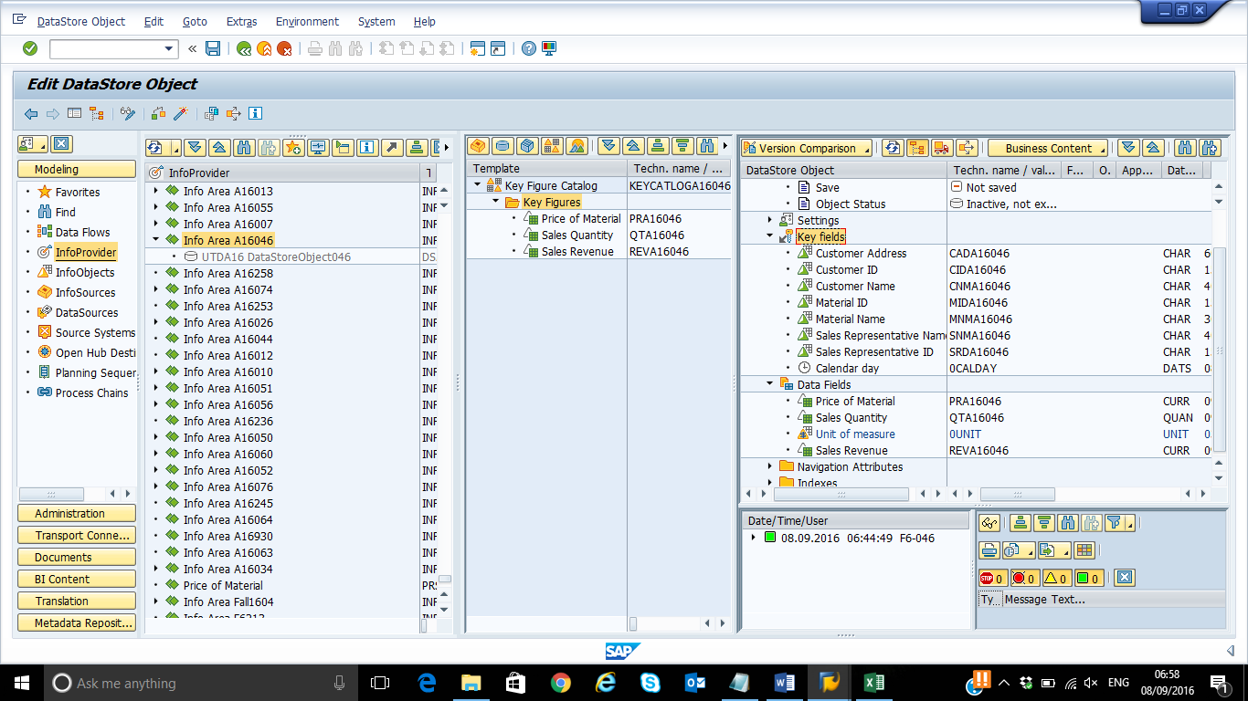

After check:

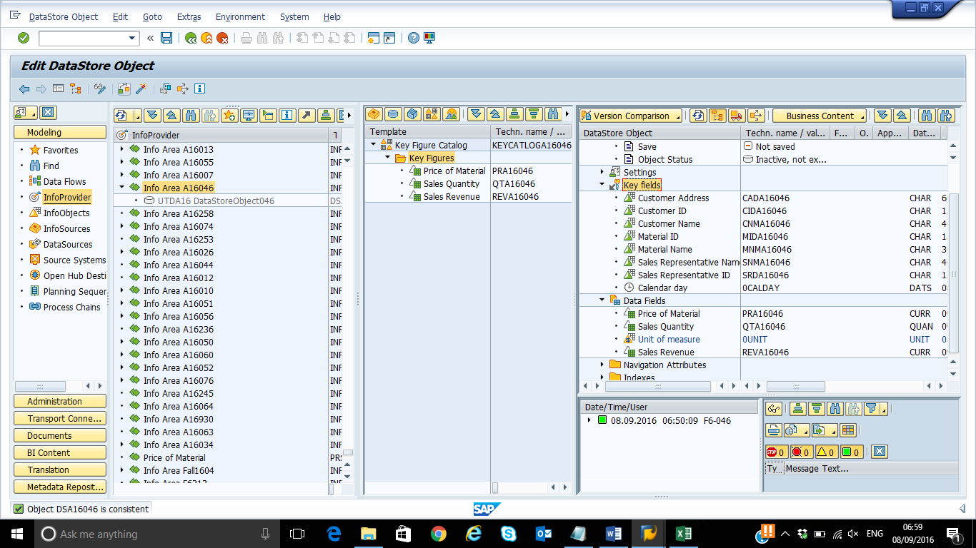

Check the DSO and Activate your DSO (DataStore Object).

(Note: You might be required to provide your SAP GUI password twice for activation process)

Show the InfoProvider tree display. Your DataStore Object now appears in your InfoArea.

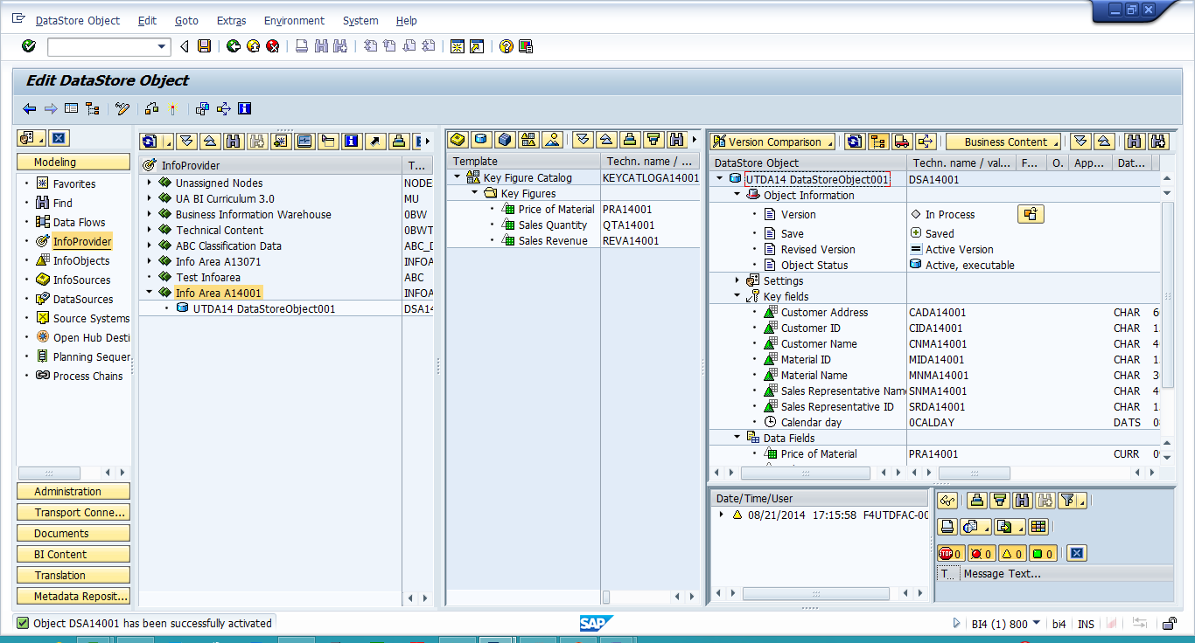

**Paste a screen show of your tree showing your DataStore Object.**

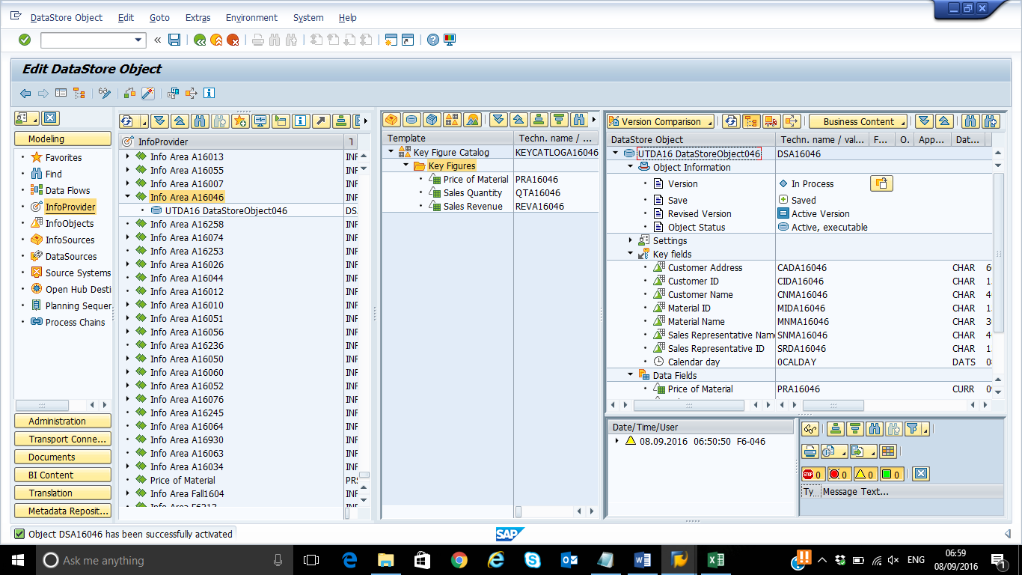

**Create Source System**

Run Transaction RSA1 in the command prompt



OR

double click on Administrator Workbench. i.e. SAP menu-> Modeling-> RSA1 – Data Warehousing Workbench: Modeling

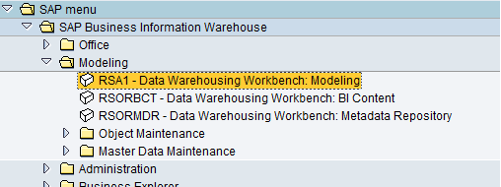

Select Source systems under Modeling in the left panel. In the right panel, right-click Source systems tab on top and select Create….

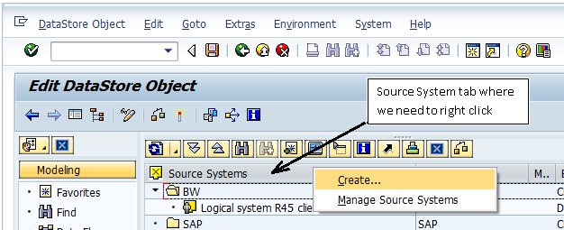

Select the File System (Manual Metadata, Data Using File Interface option), and then click continue.

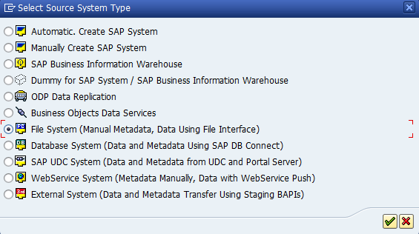

Enter the Source System Name i.e Logical System Name:**UTDSYY_XXX** and description: **UTDSYYXXSourceSystem** and click continue.(Note: XXX is your ID) It might take several minutes for the Source System to be created, so be patient.

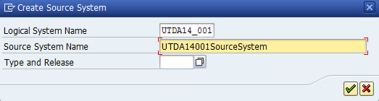

**Note down the message on the status bar-**

**Source system UTDA16_046 creation successfully finished**

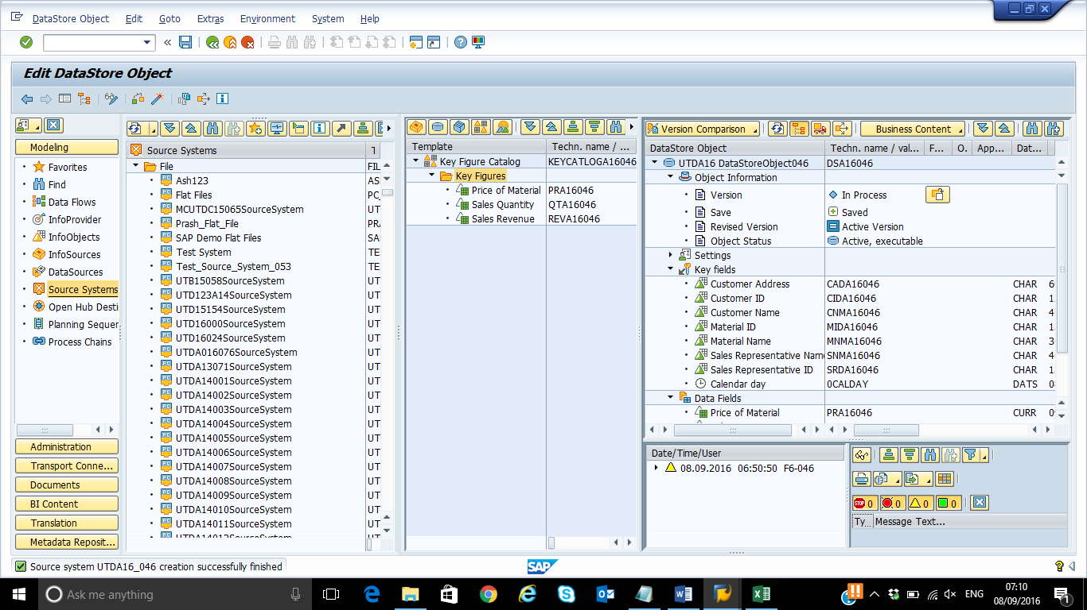

**Create an Application Component**

Select the file system you have just created **UTDXXXSYYSourceSystem** and right click and select Display DataSource Tree or double click on the source system created.

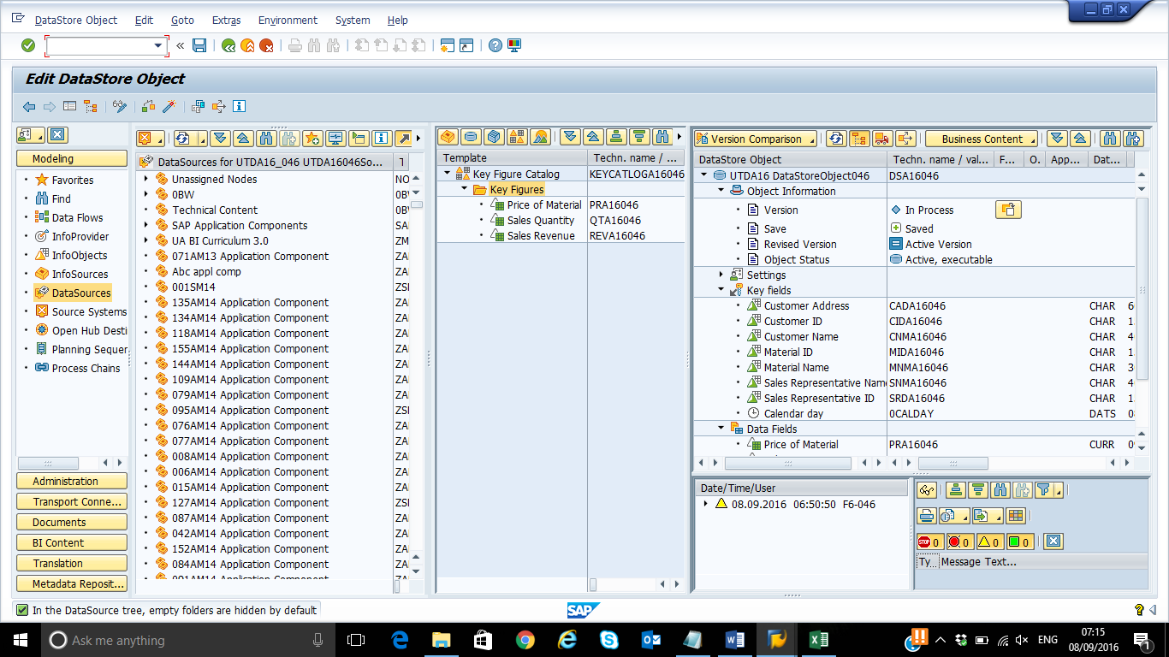

On the right panel, right-click the on the DataSource for (Your source System name) eg: DataSource for **UTDSYY_XXX** (on the Top) and select Create application component….

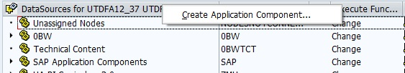

Enter a Name: **SM_AC_YYXXX** and a Description: **XXXSMYY Application Component** for the application component, and then click continue.

Click continue if you get any pop-up window.

**Write down the status message.**

**No message is displayed.**

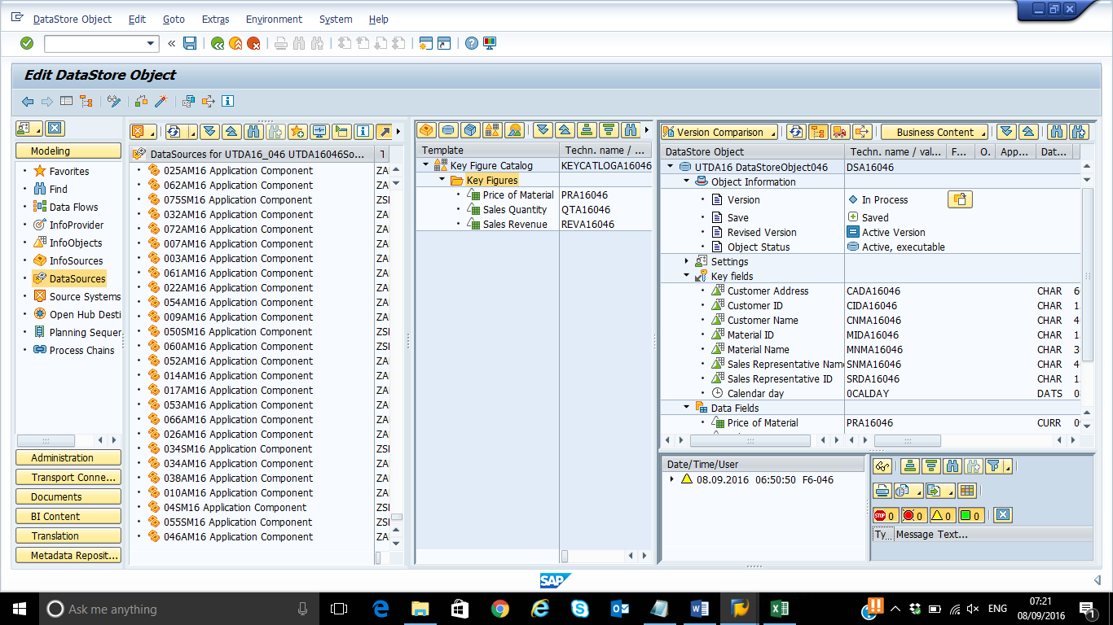

**Creating DataSource**

**Note:** The steps are almost identical to those for the master data DataSource.

Go to transaction RSA1 and choose “DataSources” in Modeling view.

Right click your Application Component (**XXXSMYY Application Component**) and select “Create DataSource” option, write ‘UTDSMYY_TD_XXX’ as ‘DataSource’ name and choose ‘Transaction Data’ as the data type.

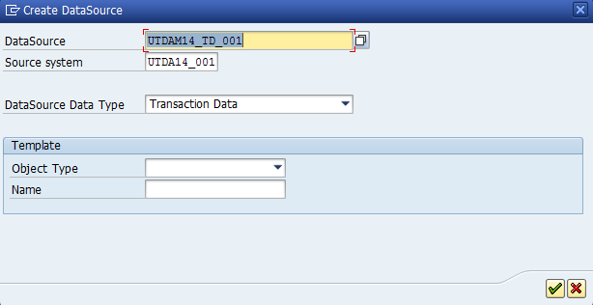

Enter the short description ‘UTDSMYYXXX TD’.

Choose the ‘Extraction’ tab and select ‘No DTP allowed for Direct Access’. This means that the data are loaded from the PSA.

-Select the right CSV file

-Header rows to be ignored: 1

-Data format ‘CSV’

-Data separator: comma ‘,’

-Number format: ‘Direct Input’

-Decimal point separator ‘,’

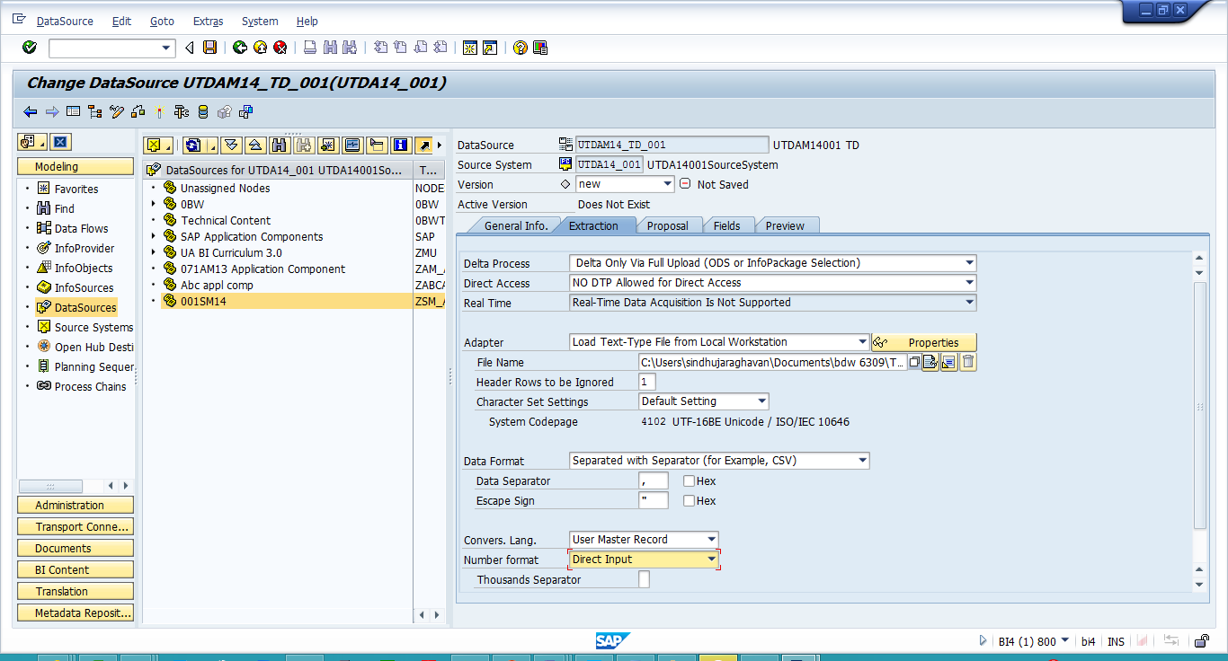

Select the ‘Proposal’ tab and click on ‘Load Example Data’ to view the data with proposed field names and attributes.

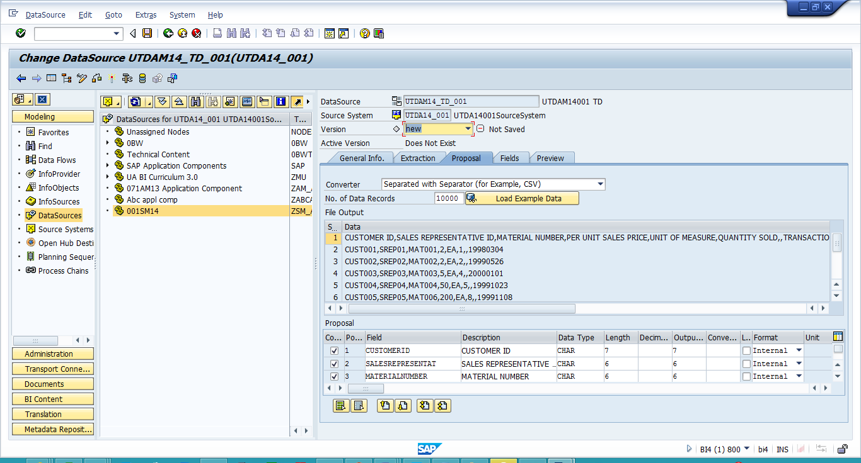

Save and activate the DataSource.

Go to ‘Preview’ tab and click on ‘Read Preview Data’.

**Paste your screen shot here:**

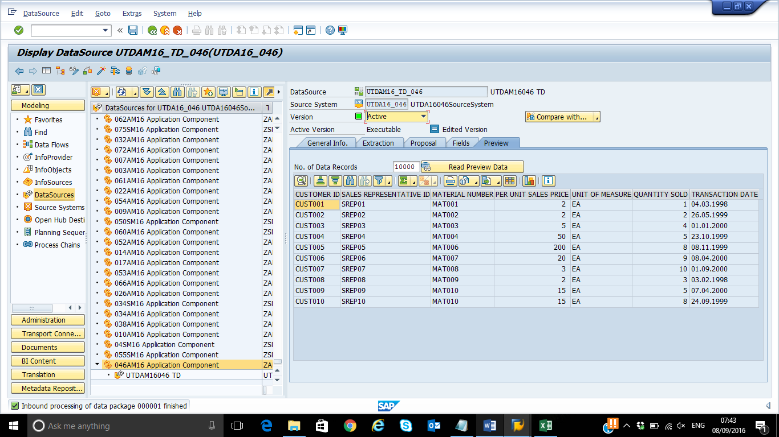

**Creating InfoPackage**

Right click the Data Source you created in step 4 and choose ‘Create InfoPackage’.

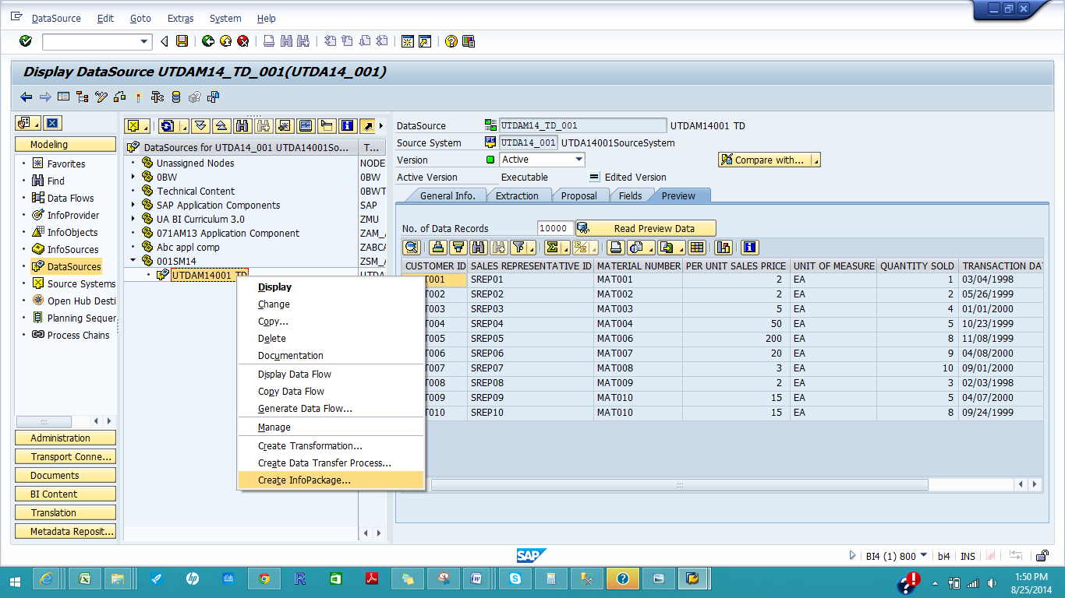

Enter description ‘Load Sales into PSA (**UTDSMYY_XXX**)’ and click on ‘Save’.

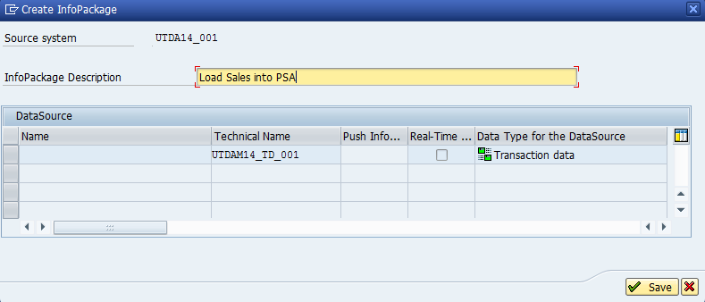

Click on ‘Save’ icon .

Click on ‘Schedule’ tab and then ‘Start’. You will receive a message saying that data was requested.

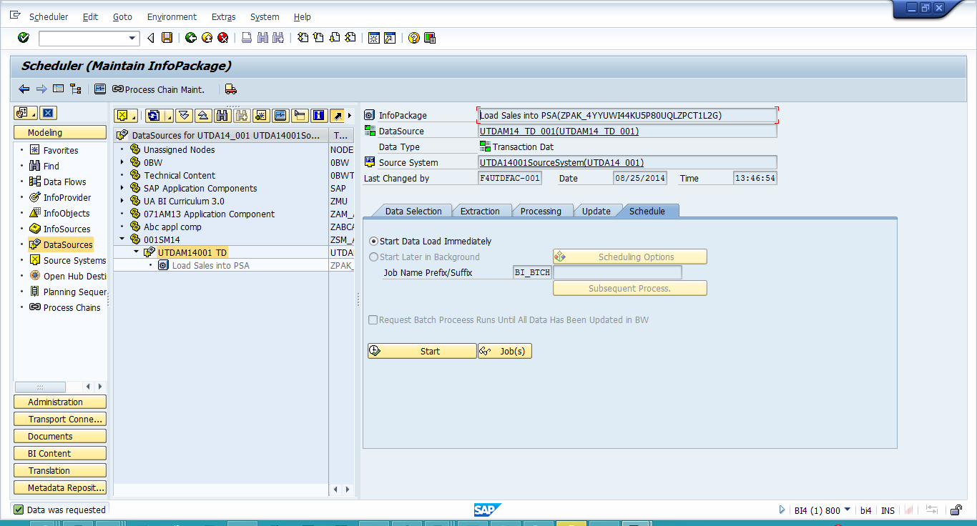

Hit ‘F6’ or click on Monitor icon. , then click the ‘PSA Maintenance’ icon . You will see the data packages successfully loaded.

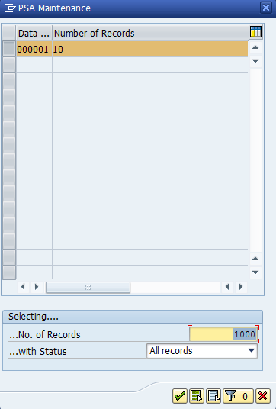

Click on the green check mark. You should have the following records:

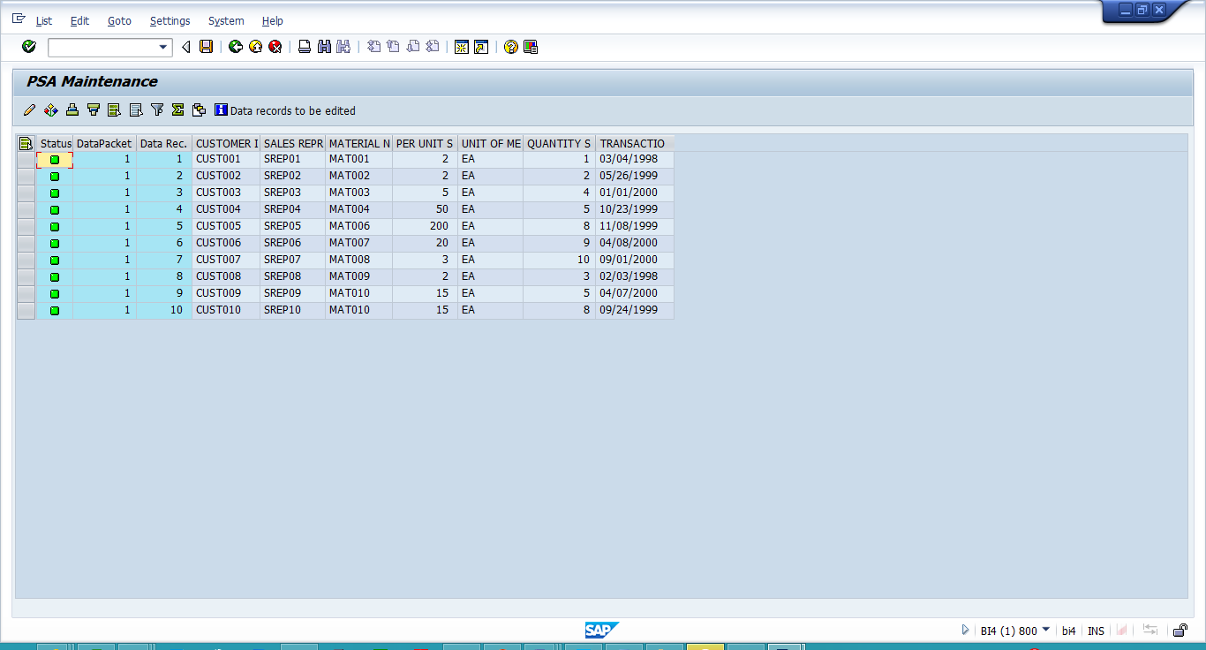

Hit ‘Back’ button thrice till you get to the ‘Display Data Source’ screen.

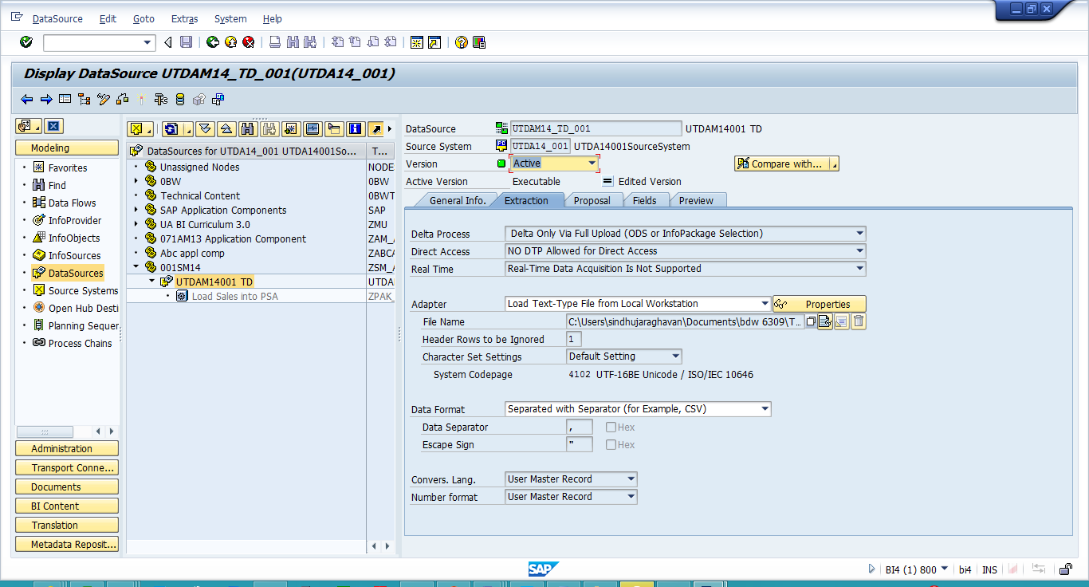

Select the ‘Proposal’ tab and click on ‘Load Example Data’ to view the data with proposed field names and attributes.

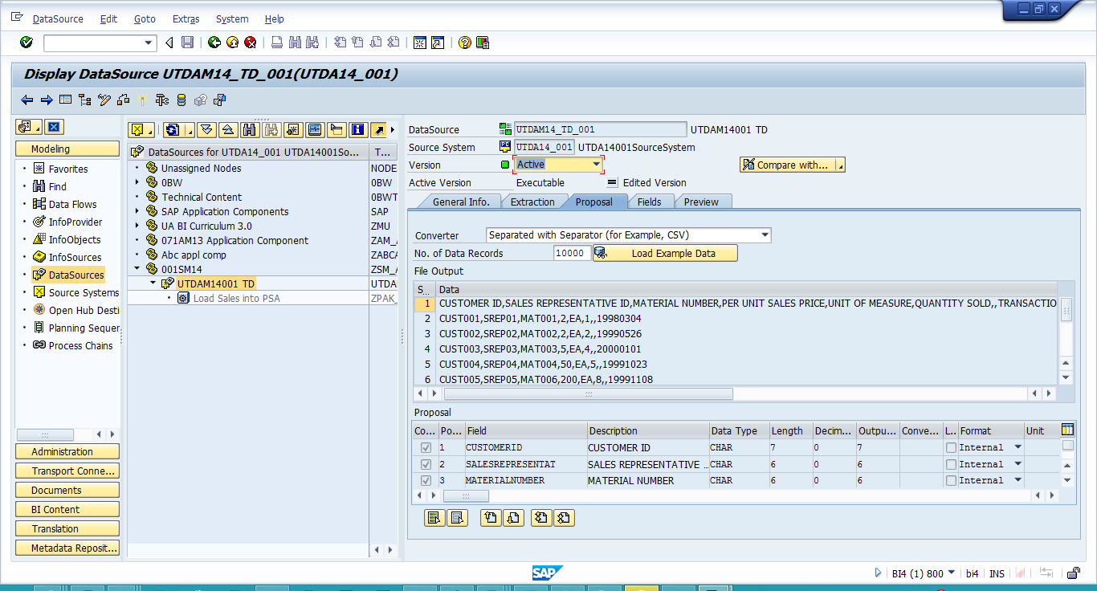

Go to ‘Preview’ tab and click on ‘Read Preview Data’. Paste your **screen shot here**

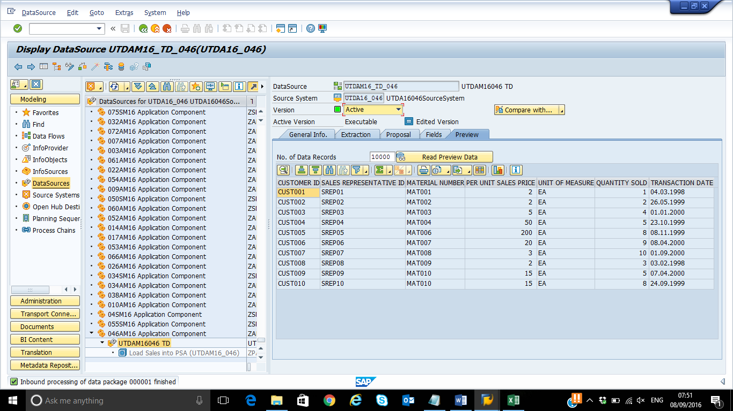

**Creating Transformation**

Right click your DataSource ‘UTDSYYXXX TD’ and select ‘Create Transformation’.

Select ‘DataStore Object’ as Object Type and type ‘DSSYYXXX’ as Name:

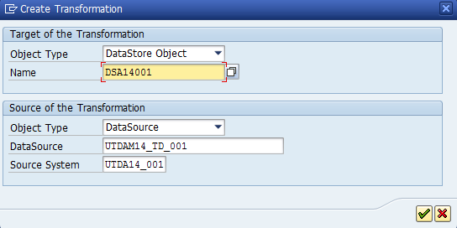

Note: You might receive ‘Cannot generate proposal’ message. Just click the green check mark. Make the connections as shown below:

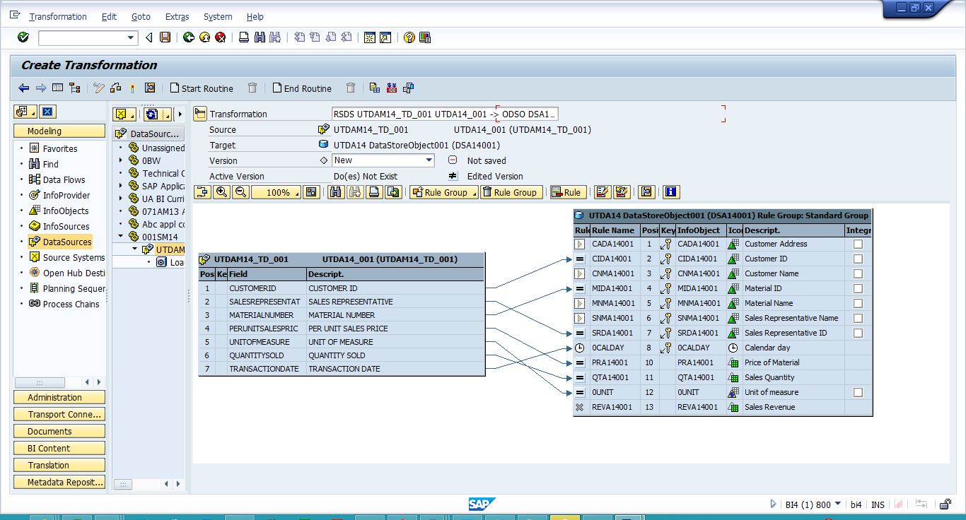

Click on ‘Activate’ icon and on the next message select the green check mark.

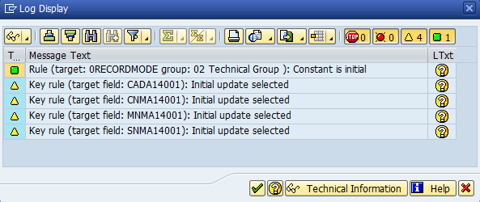

**What system message you receive after activating the transformation?**

**Transformation activated successfully**

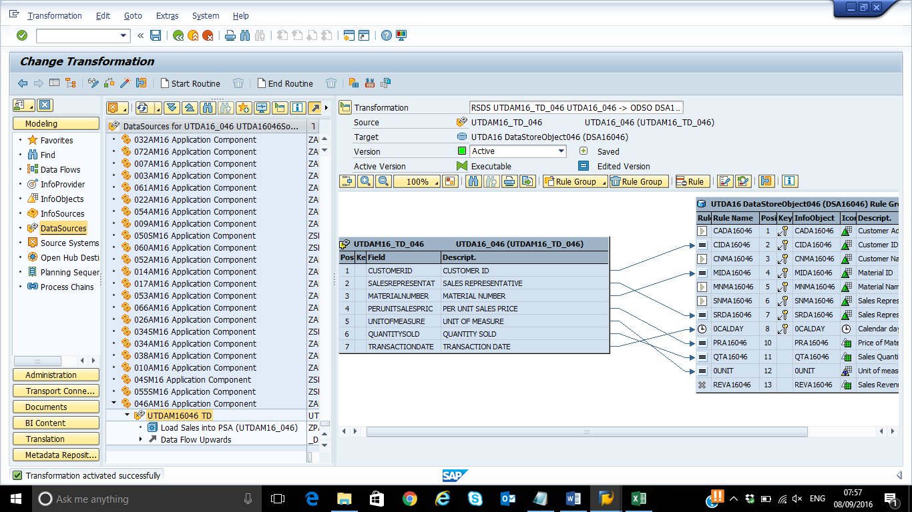

**Creating DTP**

Click on ‘Refresh subtree’ icon. 

Right click your DataSource ‘UTDSYYXXX TD’ and select ‘Create Data Transfer Process’ then select the green check mark.

In ‘Extraction’ tab choose ‘Full’ as Extraction mode and activate the Data Transfer Process.

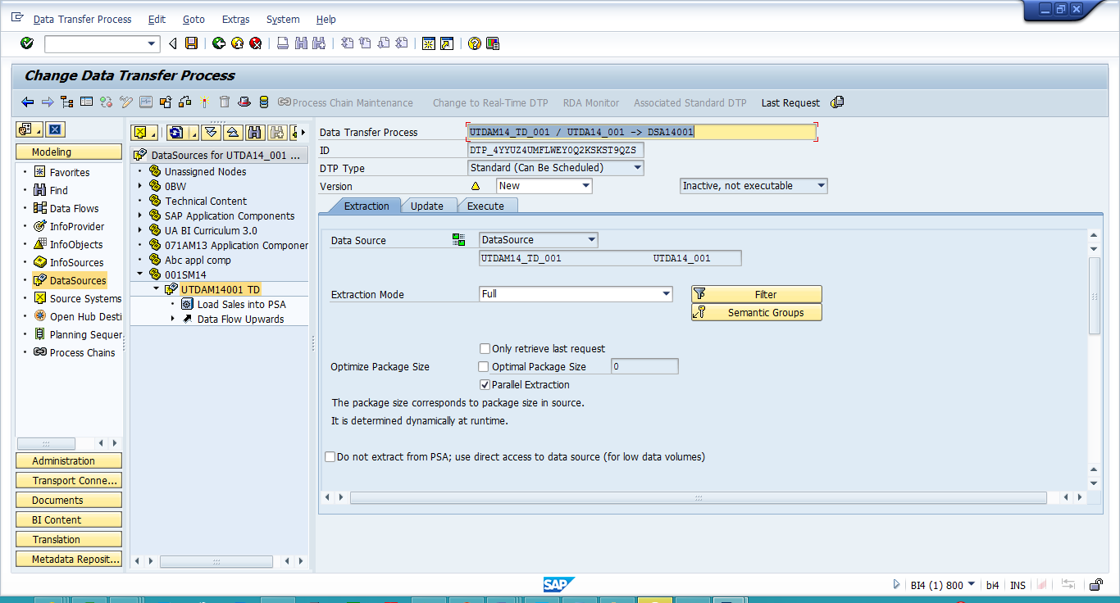

Check and Activate then go to ‘Execute’ tab and hit ‘Execute’.

To the question ‘Do you want to display the request monitor’ select ‘Yes’.

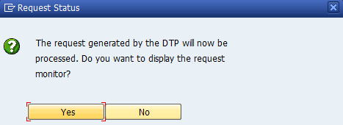

**Paste a screen shot of your monitor**

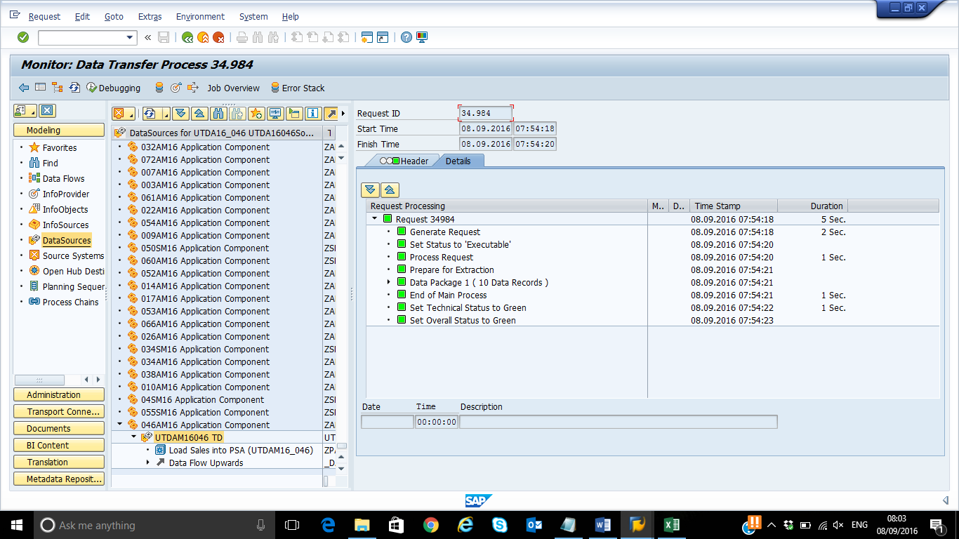

Click on ‘Administer Data Target’ icon.

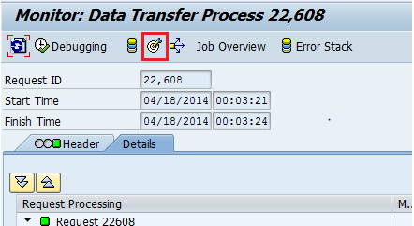

The data loaded into the DSO are considered ‘New’ and are not yet ‘Active’ for reporting purposes.

Choose the ‘Contents’ tab. Select to view the New data.

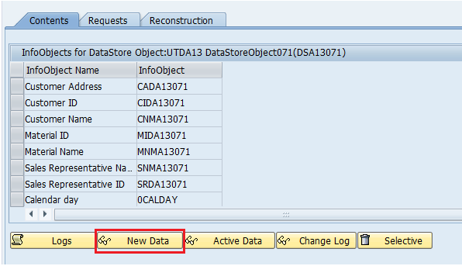

Click on the ‘Number of Entries’ and you will see the number of rows loaded from the PSA. Close the window.

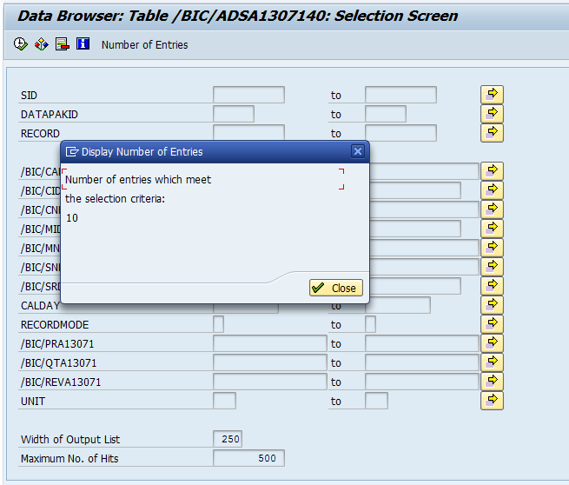

Repeat the process for Active Data.

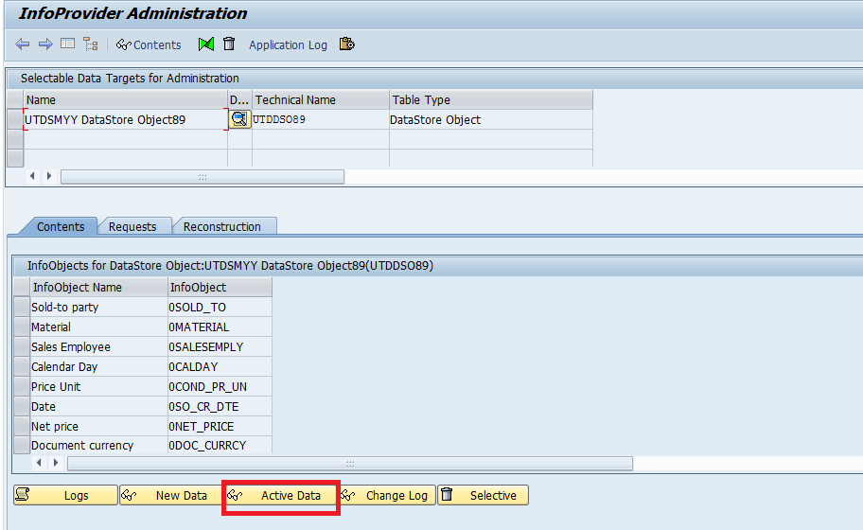

You will see that there are no entries to meet the selection criteria.

Select the Requests tab and click ‘Activate’.

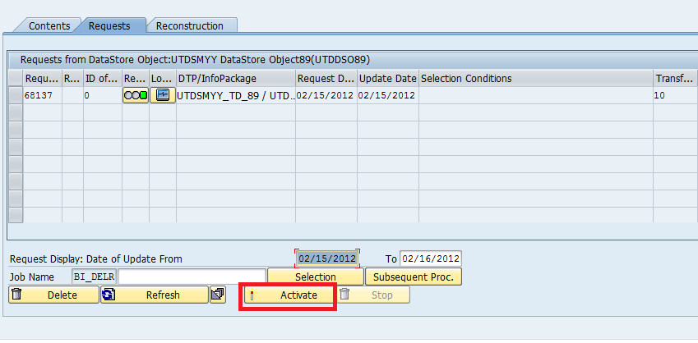

Select the request in order to activate the new data and click ‘Start’.

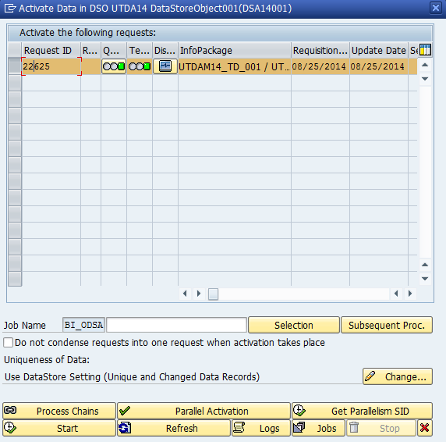

**Paste Screen Shot with status message in the background.**

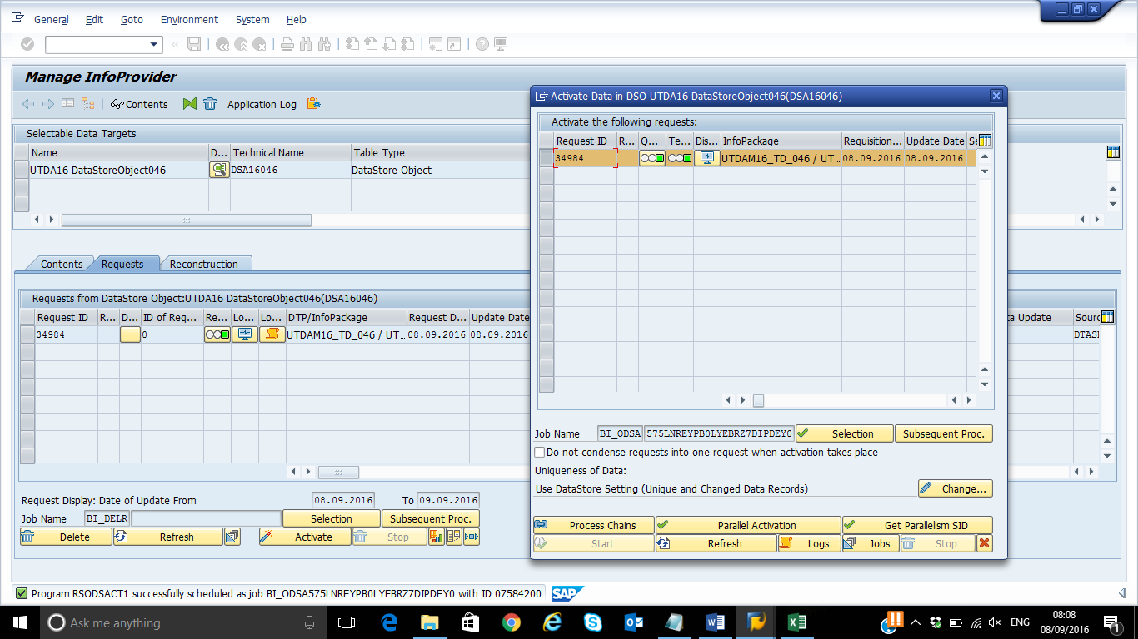

Go back to the ‘Contents’ tab and display number of entries for Active data.

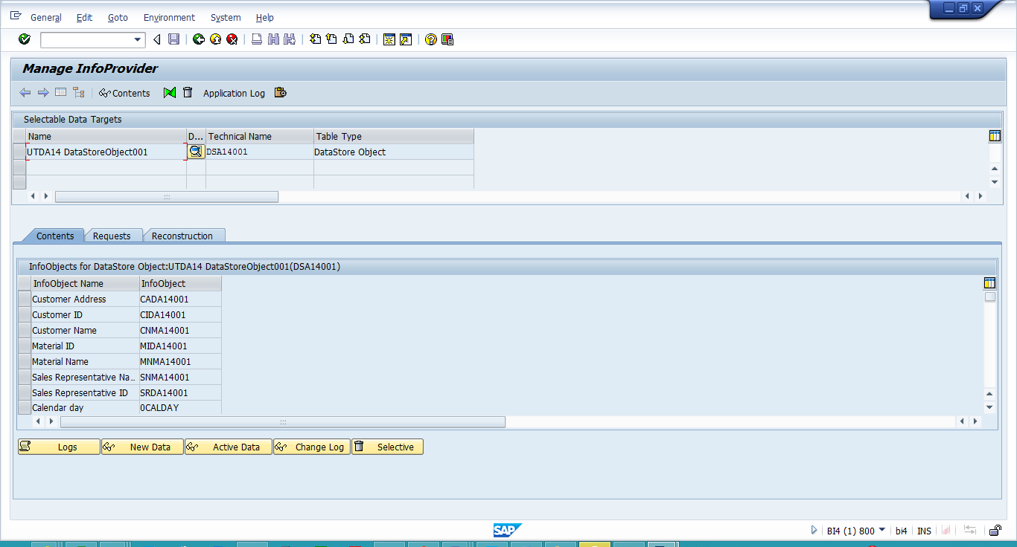

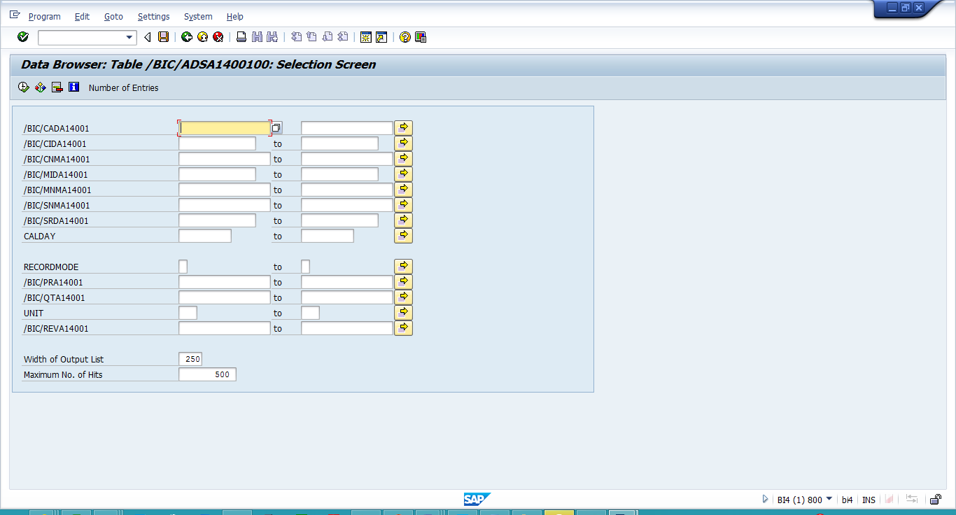

**How many are there now?**

**10**

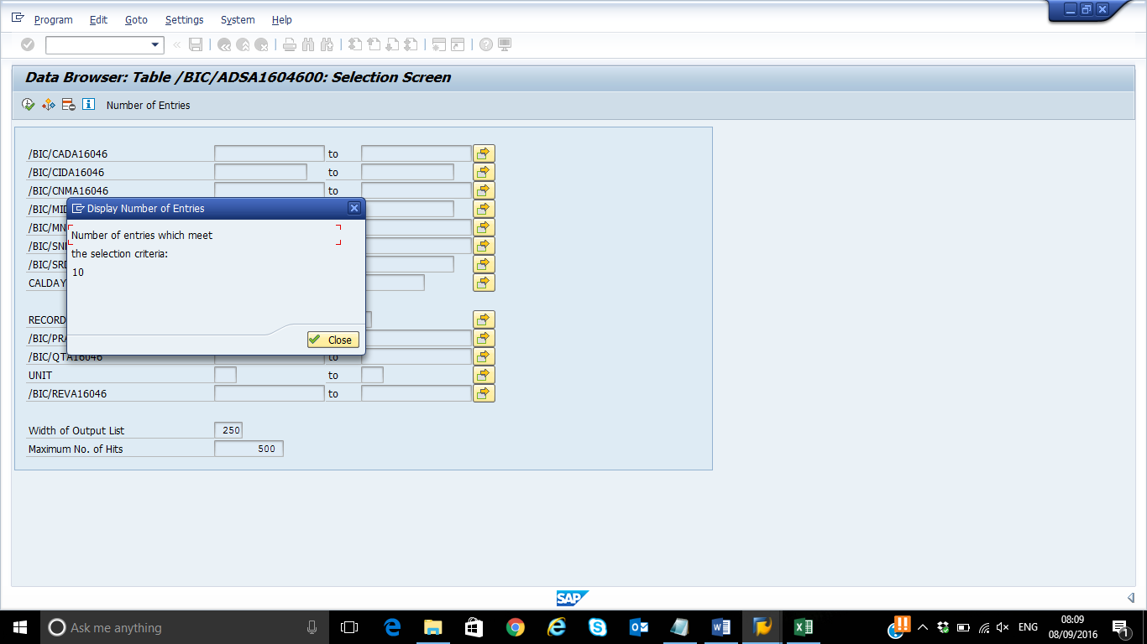

**Listing Output:**

Under Modeling choose Data InfoProvider, right click on DSSYYXXX and choose Display Data.

On the Selection Screen Hit the **FldSelectn for Output**.

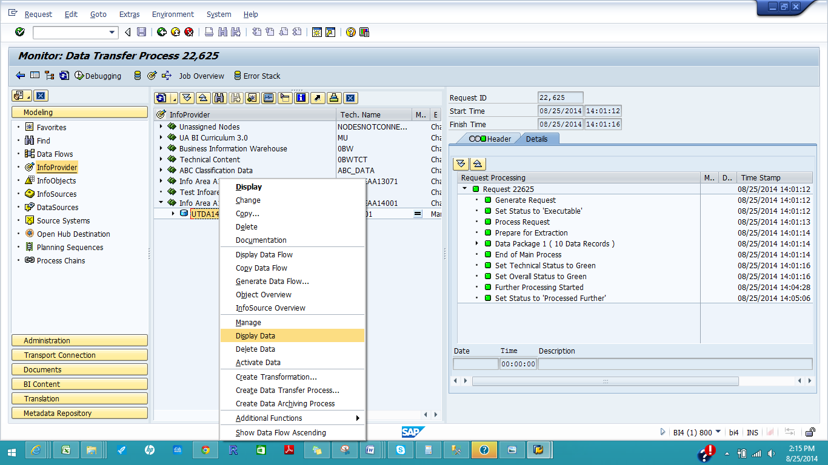

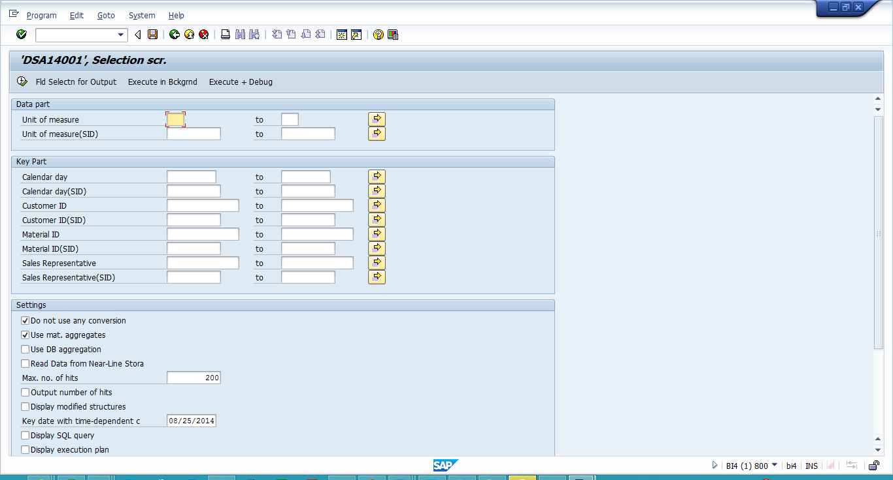

**Select all the fields listed**:

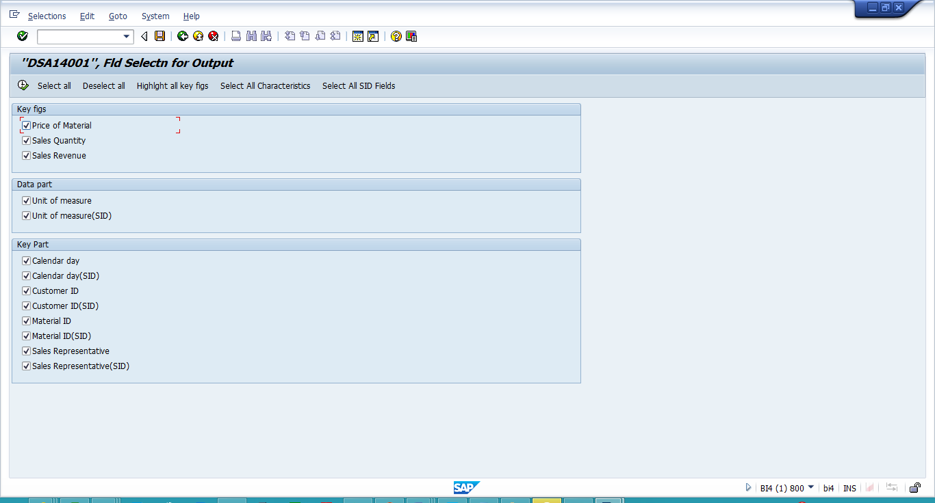

Hit Execute. And Hit Execute again on Selection Screen.

**Paste the screen shot of the List Output:**

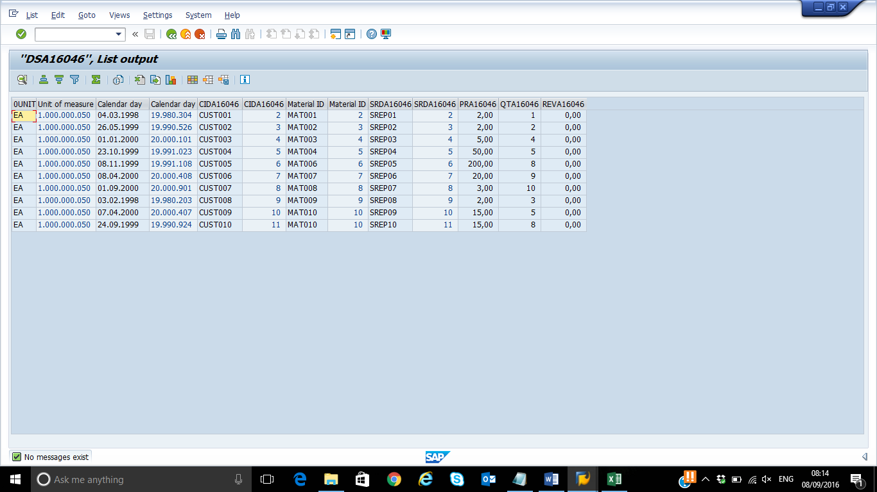

**PART 3: InfoCubes**

This part is designed to help the student acquire the ability to

* Create InfoCube
  + Add Characteristic- Here we need to create Dimension for the characteristic we have added.
  + Add Time Characteristics
  + Add the KeyFigures

**1)Create the InfoCube (Actual)**

Select InfoProvider under Modeling in the left panel. In the right panel, right-click the InfoArea created while creating InfoObjects (**InfoAreaSMYYXXX**) and then select Create InfoCube.

**Note**: The InfoObjects created by you will not be visible as you are in the InfoProvider section. For that, Click Refresh Subtree icon above the InfoProvider. If, for some reason you still are not able to see your InfoArea, please execute transaction RSA1 again.

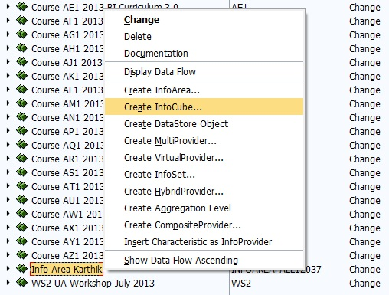

Enter a name: **CBSMYYXXX** and a description: Info Cube **SYYXXX**, select the option Standard InfoCube in block InfoCube type, and then click create the InfoCube.

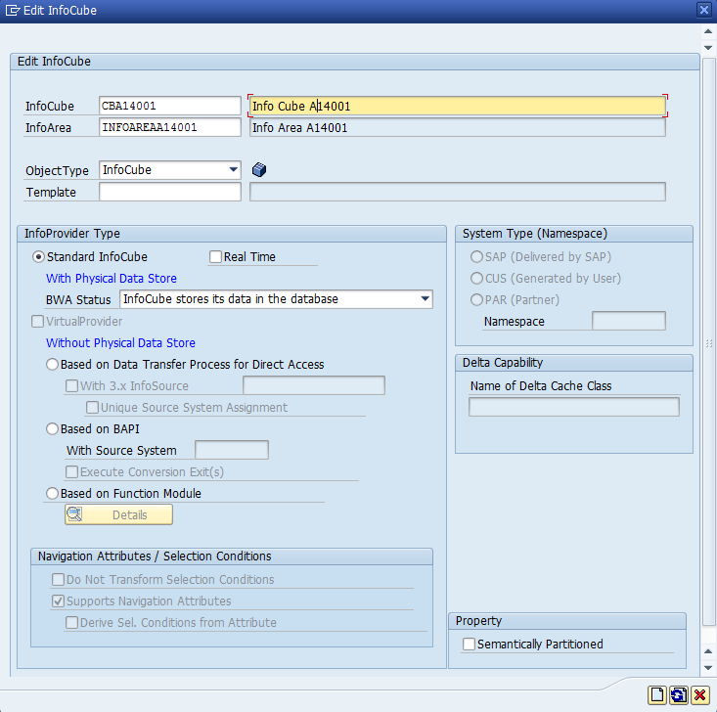

Right click the Dimensions (on right panel), create the Dimensions.

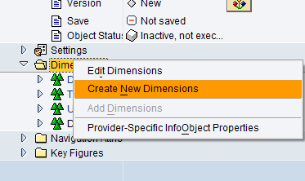

In the new window enter the Description as Customer and Click  to create another Dimension (do not worry about the added number “2” at the end of the dimension name). This is automatically generated technical name and because **CBSMYYXXX1** already would have been created by the time you are executing this step; the next available dimension name would be **CBSMYYXXX2**. Later in this exercise we will use the **CBSMYYXXX1** for our material dimension.

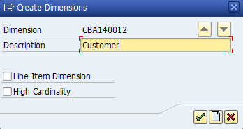

Create dimension for Sales Representative. Description **SalesRep** and Click Continue this time.

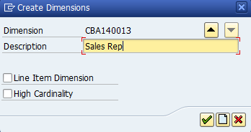

Now we will rename the default created **Dimension** Right click on the Dimension, here it is Dimension 1 and select Properties.

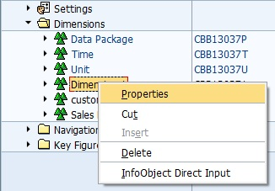

Change the Description to Material and click Continue.

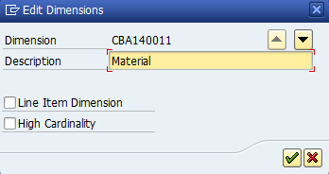

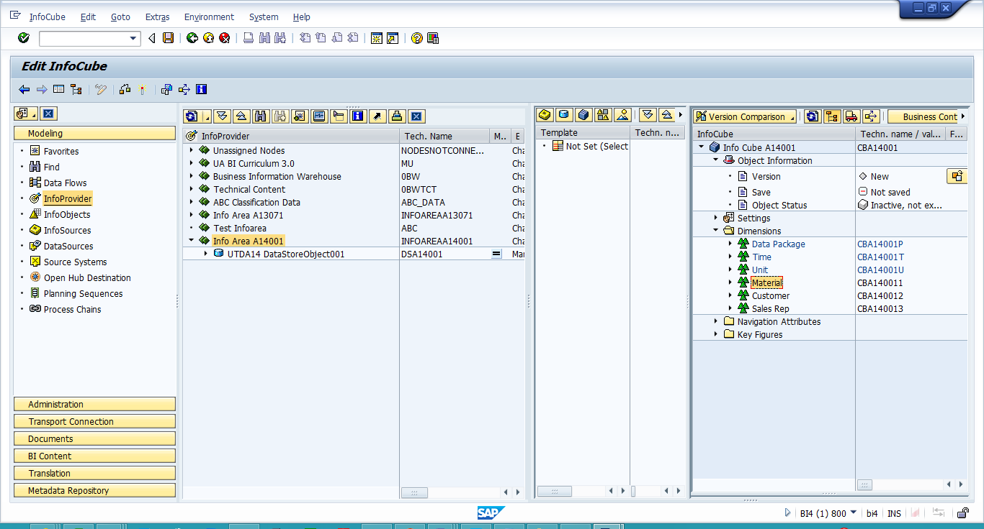

Info Object Catalog icon that will show your created infoobjects, in order to add them to respective dimensions.

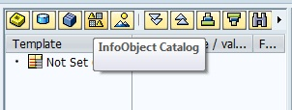

Select (click once on) Character Catalog and press green “continue” button.

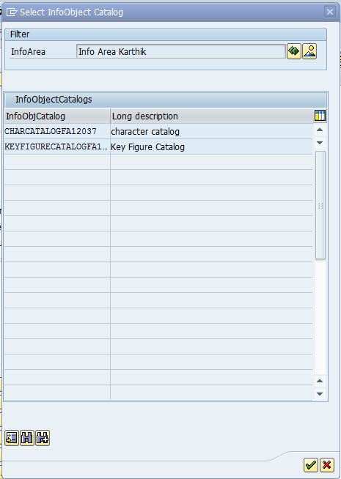

Expand the Characteristic folder to select the Customer ID(**CISYYXXX**), Material ID (**MISYYXXX**) and Sales Rep ID (**SRSYYXXX**) created in the previous steps under Template, and move them to their Dimension by Drag and Drop.

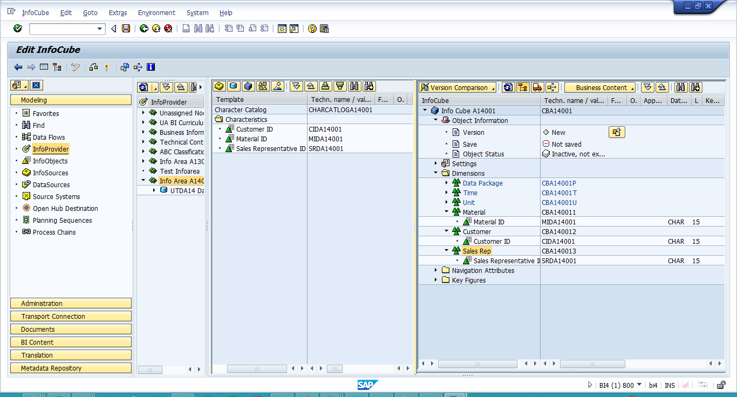

Now repeat the above steps, but this time for Key Figure Catalog (Material Price (**PRSYYXXX**), Sales Quantity(**QTSYYXXX**) and Sales Revenue(**RVSYYXXX**) and move them to Key figure folder under the cube by drag and drop.

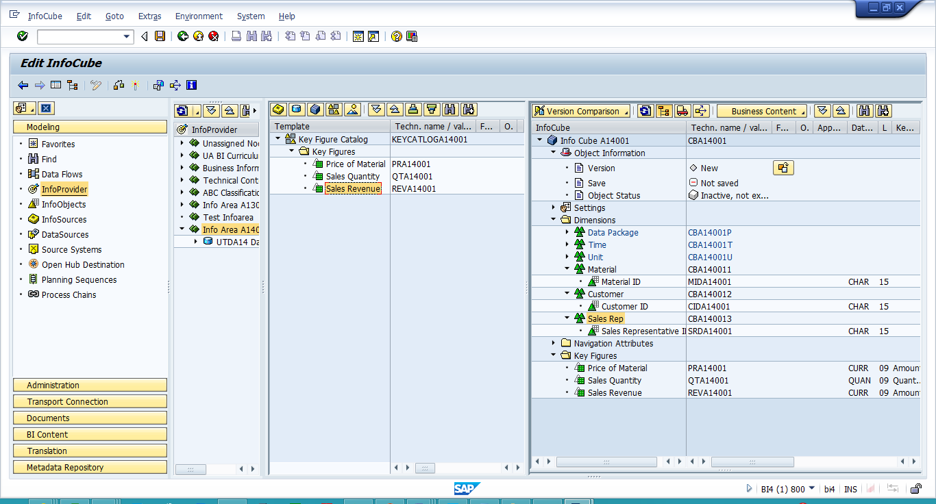

We are going to add one more Characteristic. That is the Time Characteristic **0CALDAY**.

For that purpose, we first need to click on the All Info Objects icon:

Select the Time characteristics folder in the template now, select **0CALDAY** from the Template, and drag and drop it to the Time Dimension.

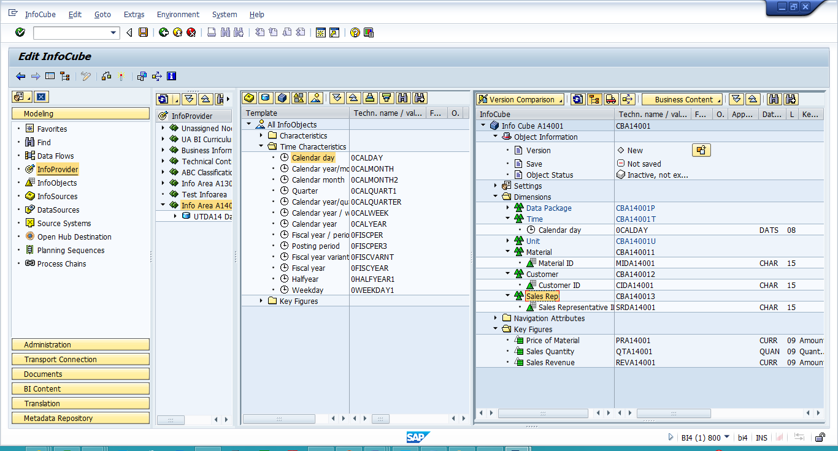

Next, click to check the InfoCube.

**Write the status Message.**

**Object CBAM16046 is consistent**

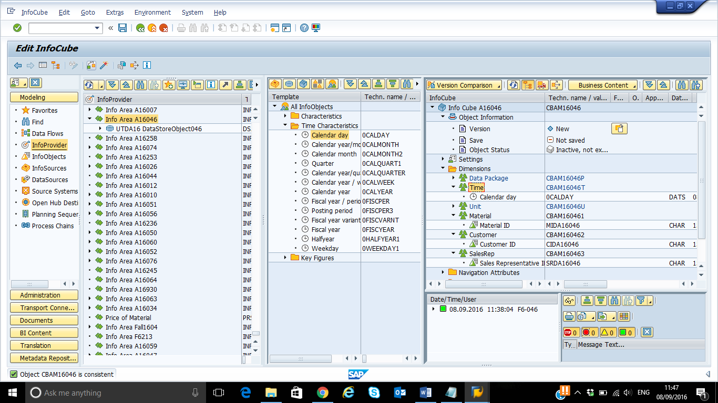

If it is valid, click to activate the InfoCube

**Paste a Screen Shot for the Info Cube created. Make sure the characteristics and key figures are visible.**

